Final Year Project Report
Aegis Ai

Project Advisor:

Sir Hassan Bashir

Submitted By:

M. Amish | F2022266402
Alika Jamil | F2022266020
Wajheea Shezad | F2022266038
Imaz Khalid | F2022266714

Session

2025-2026

University of Management and Technology
C-II Johar Town Lahore Pakistan

Dedication

All praise and gratitude belong to Allah Almighty, the Most Merciful and the Most Compassionate, who granted us health, patience, knowledge, and the ability to complete this Final Year Project. Without His countless blessings, guidance, and mercy, the successful completion of this work would not have been possible. We humbly dedicate this project to our beloved parents, whose unconditional love, sincere prayers, continuous sacrifices, and moral support have been a constant source of strength throughout our academic journey. Their guidance and faith in us motivated us to remain steadfast and focused on our goals.
We also dedicate this work to our respected teachers, supervisors, and mentors, whose valuable knowledge, constructive guidance, and sincere efforts played a significant role in shaping our academic and professional development. Their mentorship helped us enhance our understanding and complete this project with discipline and dedication. We extend our heartfelt gratitude to all those who supported us directly or indirectly during this journey. May Allah Almighty reward them all for their kindness, patience, and contributions, and accept this effort as a means of benefit and success in this world and the Hereafter.

Final Approval

- Head of Department ______________________
Department of Informatics & Systems
School of Systems & Technology
UMT Lahore

- Director (Final Year Projects-CS) ______________________
Department of Computer Science.
School of Systems & Technology
UMT Lahore

- Supervisor ______________________
- Department of Informatics & Systems.
- School of Systems & Technology
UMT Lahore

- Co-Supervisor ______________________

Acknowledgment

Traditional surveillance systems largely depend on manual monitoring of recorded video footage, which makes the process inefficient, labor-intensive, and highly susceptible to human error. In environments such as public places, educational institutions, commercial buildings, and transportation hubs, reviewing large volumes of surveillance footage becomes increasingly difficult, often resulting in delayed or missed detection of critical security incidents. This limitation emphasizes the need for intelligent surveillance systems capable of automatically analyzing recorded videos and identifying potential threats in a timely and reliable manner.
This Final Year Project proposes Aegis AI, an intelligent security surveillance system that utilizes deep learning and computer vision techniques to analyze pre-recorded surveillance video streams. The system is designed to automatically detect and analyze suspicious activities without human intervention. YOLOv8 is employed for accurate object and weapon detection within video frames, enabling the identification of potentially dangerous items. To enhance behavioral understanding, pose estimation techniques are used to recognize violent or abnormal human actions. Additionally, temporal analysis is applied across video sequences to identify activities such as abandoned objects and abnormal crowd density patterns over time.
Upon detecting a suspicious event, the system extracts key evidence in the form of snapshots and relevant metadata, which are securely stored in a centralized database for further review and investigation. A web-based dashboard is developed to allow security personnel to visualize detected incidents, review analyzed footage, and access analytical summaries, thereby supporting informed decision-making. The proposed system aims to significantly reduce dependency on manual video inspection, improve detection accuracy, and enhance overall surveillance efficiency. By automating the analysis of recorded surveillance footage, Aegis AI provides a scalable and intelligent security solution suitable for deployment in both public and private environments.

Project Title:
Aegis AI: AI-Powered Smart Security and Surveillance System using Deep Learning

Supervised by:
Sir Hassan Bashir

Starting Date:
October 2026

Completion Date:
May 2026

Tools Used:
Python, YOLOv8, FastAPI, React, PostgreSQL

Operating System:
Windows / Linux

Documentation:
Microsoft Word

Plagairism Report

This section presents the plagiarism analysis conducted for the Aegis AI – Smart Security Surveillance System. The purpose of this analysis is to ensure the originality of the project documentation and implementation while adhering to academic integrity policies. The plagiarism check was performed using an automated similarity detection tool (e.g., Turnitin). The analysis confirms that the majority of the content is original, including system design, implementation details, algorithms, diagrams, and experimental results. Any similarity detected originates from standard technical terminology, properly cited research papers, and commonly used definitions in the field of artificial intelligence and computer vision. It is important to note that this project uses pre-recorded videos and publicly available image datasets solely for training, testing, and validation purposes. These datasets are referenced appropriately, and no copyrighted content has been misused. The AI models were trained and evaluated independently, ensuring originality in results and system behavior.
Plagiarism Summary Table
Document Component | Similarity Percentage | Source of Similarity | Remarks
Abstract | 5% | Technical terms | Acceptable
Introduction | 8% | Definitions & cited literature | Properly referenced
Literature Review | 18% | Research papers | Fully cited
System Analysis & Design | 4% | Common UML terminology | Original content
Implementation Details | 2% | Code-related keywords | User-defined logic
Algorithms | 1% | Mathematical notations | Original
Results & Discussion | 0% | — | Fully original
Conclusion & Future Work | 0% | — | Fully original
Overall Similarity Index | 12% | — | Within acceptable limit

Abstract

Traditional surveillance systems largely depend on manual monitoring of recorded video footage, which makes the process inefficient, labor-intensive, and highly susceptible to human error. In environments such as public places, educational institutions, commercial buildings, and transportation hubs, reviewing large volumes of surveillance footage becomes increasingly difficult, often resulting in delayed or missed detection of critical security incidents. This limitation emphasizes the need for intelligent surveillance systems capable of automatically analyzing recorded videos and identifying potential threats in a timely and reliable manner.
This Final Year Project proposes Aegis AI, an intelligent security surveillance system that utilizes deep learning and computer vision techniques to analyze pre-recorded surveillance video streams. The system is designed to automatically detect and analyze suspicious activities without human intervention. YOLOv8 is employed for accurate object and weapon detection within video frames, enabling the identification of potentially dangerous items. To enhance behavioral understanding, pose estimation techniques are used to recognize violent or abnormal human actions. Additionally, temporal analysis is applied across video sequences to identify activities such as abandoned objects and abnormal crowd density patterns over time.
Upon detecting a suspicious event, the system extracts key evidence in the form of snapshots and relevant metadata, which are securely stored in a centralized database for further review and investigation. A web-based dashboard is developed to allow security personnel to visualize detected incidents, review analyzed footage, and access analytical summaries, thereby supporting informed decision-making. The proposed system aims to significantly reduce dependency on manual video inspection, improve detection accuracy, and enhance overall surveillance efficiency. By automating the analysis of recorded surveillance footage, Aegis AI provides a scalable and intelligent security solution suitable for deployment in both public and private environments.
Revision Chart
This revision chart presents the history of revisions made to this Final Year Project document. It records the version updates, contributors, brief descriptions of changes, and completion dates. The purpose of this chart is to maintain proper documentation control and to provide a clear record of modifications made throughout the development and review process. Each revision reflects improvements and updates incorporated based on supervisor feedback and evaluation requirements.

Version | Primary Author(s) | Description of Version | Date Completed
Draft | Project Group Members | Initial draft of the Final Year Project prepared for internal review and preliminary supervisor feedback. | 05-01-2025
Preliminary | Project Group Members | Revised version incorporating initial feedback, corrections, and suggestions provided by the project supervisor. | 15-01-2025
Final | Project Group Members | Final version of the project document prepared after addressing all major comments and submitted for evaluation. | 20-01-2025
Revision 1 | Project Group Members | Revised and improved version of the Final Year Project based on evaluation feedback and minor corrections. | 26-01-2025

Contents
Contents 1
Definitions and Acronyms 4
List of Figures 5
List of Tables 6
1. Introduction 7
1.1 Motivations 7
1.2 Project Overview 7
1.2.1 Overview Statement 7
1.2.2 Customer 8
1.2.3 Goals 8
1.2.4 System Functions 8
1.2.5 System Attributes 9
1.3 Problem Statement 9
1.4 Objectives 9
2. Domain Analysis 10
2.1 Customer 10
2.2 Stakeholders 10
2.3 Affected Groups with social or economic impact 10
2.4 Dependencies/ External Systems 11
2.5 Reference Documents 11
2.5.1 Related Projects 11
2.5.2 Feature Comparison 12
3. Requirements analysis 14
3.1 Requirements 14
3.1.1 Functional Requirements 14
3.1.2 Non-Functional Requirements 14
3.1.3 Data Requirements 15
3.1.4 Constraints 15
3.1.5 External Interface Requirements 15
3.2 List of Actors 17
3.3 List of use cases 17
3.4 System use case diagram 18
3.5 Extended use cases 19
3.6 User interfaces (mock screens) 26
4. Data flow diagram (optional) 29
4.1 Data Flow Diagram Level 0 29
5. System Design 30
5.1 System Architecture Diagram 30
5.2 Class Diagram 31
Error! Bookmark not defined.
5.3 Sequence Diagrams 32
5.4 Collaboration Diagrams 33
5.5 ERD 34
5.6 Data Dictionary 35
6. Implementation details 36
6.1 Development Setup 36
6.2 Deployment setup 37
6.2.1 Deployment Environment 37
6.2.2 Deployment Architecture 37
6.3 Algorithms 37
6.3.1 Video Frame Processing Algorithm 37
6.3.2 Weapon Detection Algorithm 38
6.3.3 Crowd Detection Algorithm 38
6.3.4 Abandoned Object Detection Algorithm 38
6.3.5 Alert Generation Algorithm 38
6.4 Constraints 38
6.4.1 Assumptions 38
6.4.2 System Constraints 39
6.4.3 Restrictions 39
6.4.4 Limitations 39
7. Testing 40
7.1 Extended Test Cases 40
7.2 Decision Table 44
7.2.1 Code snippet 44
7.2.2 Decision coverage table Table : Coverage Table 47
7.3 Traceability Matrix 48
7.3.1 RID vs UCID (requirements vs use cases) 48
7.3.2 Prototypes (RID vs PID) 50
7.3.3 Test Cases (RID vs TID) 50
7.3.4 Coverage (UCID vs TID) 51
8. Results/Output/Statistics 52
8.1 %completion 52
8.1.1 Objective 52
8.1.2 Methodology 52
8.1.3 Calculation 52
8.1.4 Conclusion 53
8.2 %accuracy 53
8.2.1 Objective 53
8.2.2 Test Execution Summary 53
8.2.3 Calculation 54
8.2.4 Conclusion 54
8.3 %correctness 54
8.3.1 Objective 54
8.3.2 Methodology 54
8.3.3 Coverage Summary 55
8.3.4 Calculation 55
8.3.5 Conclusion 55
9. Conclusion 56
10. Future work 57
11. Bibliography 58
11.1 Books 58
11.2 Journals 58
11.3 Articles 59
11.4 Research Papers 59
11.5 Other References 59
12. Appendix 60
12.1 Glossary of Terms 60
12.2 Pre-requisites 61
12.2.1 Hardware Pre-requisites 61
12.2.2 Software Pre-requisites 61
12.2.3 Development Tools 61
12.2.4 Dataset and Media Pre-requisites 62
12.2.5 Deployment Pre-requisites 62
12.2.6 External System Dependencies 62
12.2.7 Operational Assumptions 62

Definitions and Acronyms
Provide definitions or references to all the definitions of the special terms and acronyms used within this document

Table 1: Table of acronyms and definitions

Acronym / Term | Definition
AI | Artificial Intelligence
DL | Deep Learning
CNN | Convolutional Neural Network
YOLO | You Only Look Once – real-time object detection algorithm
YOLOv8 | Latest version of YOLO used for fast and accurate detection
CCTV | Closed-Circuit Television
FPS | Frames Per Second
API | Application Programming Interface
FastAPI | A high-performance Python web framework for APIs
UI | User Interface
DB | Database
PostgreSQL | Open-source relational database management system
SMTP | Simple Mail Transfer Protocol
RBAC | Role-Based Access Control
GPU | Graphics Processing Unit
Pose Estimation | Technique to detect human body keypoints
LSTM | Long Short-Term Memory neural network
ERD | Entity Relationship Diagram
DFD | Data Flow Diagram

List of Figures

Figure 1: use case diagram with explanation 18
Figure 2: Prototype1 Login Screen 26
Figure 3: Prototype2 Aegis Admin Dashboard Screen 26
Figure 4: Prototype3: Company Admin Dashboard Screen 27
Figure 5: Prototype4 Security Officer Screen 27
Figure 6: Prototype5 Vedio Upload Screen 28
Figure 7: Prototype6 Incident Log Screen 28
Figure 8: Level 0 DFD of Aegis AI 29
Figure 9: System Architecture 30
Figure 10: Class Diagram of Aegis AI 31
Figure 11: Sequence Diagram of Aegis AI 32
Figure 12: Collaboration Diagram of Aegis Ai 33
Figure 13: ER Daigram 34

List of Tables
Table 1: Table of acronyms and definitions 4
Table 2: list of stakeholders 10
Table 3: Feature Comparisons Table 12
Table 4: Requirements Table 16
Table 5: Extended use case 1 19
Table 6: Extended use case 2 20
Table 7: Extended use case 3 21
Table 8: Extended use case 4 22
Table 9: Extended use case 5 23
Table 10: Extended use case 6 24
Table 11: Extended use case 7 25
Table 12: Data Dictionary Table 35
Table 13: Software Tools and Technologies 36
Table 14: Challenges Faced & Solutions 37
Table 15: Extended Test Case1 40
Table 16: Extended Test Case 2 41
Table 17: Extended Test Case 3 42
Table 18: Extended Test Case 4 43
Table 19: Extended Test Case 5 44
Table 20: Coverage Table 47
Table 21: RID vs UCID 48
Table 22: RID vs PID 50
Table 23: RID vs TID 50
Table 24: UCID vs TID 51
Table 25: completion % calculation 52
Table 26: accuracy summary 53
Table 27: accuracy % calculation 54
Table 28: Coverage summary 55
Table 29: Glossary of terms table 60

Introduction
The rapid growth of urban environments and public infrastructure has led to an increased reliance on surveillance systems to ensure safety and security. Closed-Circuit Television (CCTV) cameras are widely deployed across educational institutions, commercial complexes, transportation hubs, and public spaces. However, despite the extensive availability of recorded surveillance footage, most existing systems lack intelligent mechanisms for automated analysis and continue to rely heavily on manual monitoring.
This Final Year Project, titled "Aegis AI: AI-Powered Smart Security and Surveillance System using Deep Learning", focuses on developing an intelligent system capable of analyzing uploaded surveillance video footage to automatically detect security threats, with optional prototype live-camera monitoring. By integrating modern deep learning models and computer vision techniques, the system aims to enhance surveillance effectiveness, reduce human workload, and improve incident detection accuracy. This chapter introduces the motivation, project overview, problem statement, and objectives of the proposed system.

Motivations
The motivation for this project arises from the limitations of traditional surveillance systems that depend on human operators to review recorded video footage. In environments where hundreds of cameras generate continuous recordings, manual inspection becomes impractical and inefficient. Security personnel often face fatigue, distraction, and time constraints, which significantly increase the risk of overlooking critical events such as violent incidents, weapon presence, or suspicious behavior.
Recent advancements in artificial intelligence, particularly in deep learning and computer vision, have demonstrated significant improvements in object detection and activity recognition tasks. Algorithms such as YOLOv8 have achieved high accuracy and speed in identifying objects within images and videos. Similarly, pose estimation and temporal analysis techniques enable the understanding of human behavior over time.
The motivation behind Aegis AI is to leverage these technological advancements to create an automated surveillance system that can intelligently analyze uploaded video footage, detect potential threats, generate alerts, and assist security personnel in decision-making. By reducing reliance on manual monitoring, the system aims to improve response time and overall security effectiveness.

Project Overview

Overview Statement
Aegis AI is an intelligent surveillance system designed to automatically analyze uploaded CCTV video footage using deep learning-based computer vision techniques. The system processes video data to detect weapons, violent behavior, abandoned objects, face obfuscation, and abnormal crowd density. Detected incidents are logged along with visual evidence and metadata, and alerts are delivered via Email and SMS to assigned security personnel. Results can be reviewed through a multi-tenant web-based dashboard with role-based access control. Prototype live RTSP camera monitoring is also supported for selected deployments.

Customer
Although this project does not involve a formally contracted client, the intended users and potential customers include:
- Educational institutions (universities, schools)
- Commercial buildings and shopping malls
- Transportation authorities
- Private security firms
- Corporate organizations with CCTV infrastructure
These organizations require efficient analysis of uploaded surveillance footage for security auditing, incident investigation, and compliance purposes.

Goals
The primary goals of the project are:
To automate the analysis of uploaded surveillance videos
To reduce the dependency on human monitoring
To detect suspicious activities with high accuracy
To generate Email and SMS alerts for high-risk incidents
To store and manage evidence for post-incident analysis
To provide an intuitive dashboard for reviewing detected incidents and analytics

System Functions
The major functions of the proposed system include:
Automated object and weapon detection using YOLOv8
Violence and aggression detection using a Conv3D temporal classifier
Face obfuscation and mask-violation detection using YOLOv8
Temporal analysis for abandoned object detection
Crowd density estimation using SANet/CSRNet from recorded footage
Evidence logging with timestamps, threat levels, and confidence scores
Email and SMS alert generation with zone-based officer routing
Incident visualization and analytics through a React web-based dashboard
User authentication and role-based access control across multi-tenant companies
Prototype live RTSP camera preview and background AI inference

System Attributes
The system is designed with the following attributes:
Accuracy: Reliable detection of threats across multiple AI modules
Scalability: Modular architecture supporting multiple companies and large video volumes
Security: Role-based access control and company-scoped data isolation
Usability: Simple and intuitive dashboard interface with analytics views
Maintainability: Modular and extensible FastAPI + React architecture

Problem Statement
Despite the widespread installation of CCTV systems, the process of monitoring surveillance footage remains largely manual and inefficient. Large volumes of video data make it difficult for security personnel to review footage effectively, leading to delayed or missed detection of critical security incidents. Traditional systems lack intelligent capabilities for identifying weapons, violent behavior, abandoned objects, face obfuscation, or abnormal crowd conditions, and they rarely provide automated alert routing to the right personnel. Consequently, these systems are reactive rather than proactive, responding only after incidents have occurred. There is a clear need for an automated surveillance system that can intelligently analyze uploaded video footage, detect suspicious activities accurately, notify relevant staff in a timely manner, and provide structured evidence to support security investigations and decision-making.

Objectives
The objectives of this project are as follows:
To design and implement an AI-based surveillance system for analyzing uploaded video footage
To detect weapons and suspicious objects using deep learning models
To identify violent or aggressive human behavior using a Conv3D temporal classifier
To detect face obfuscation and mask violations using YOLOv8
To detect abandoned objects using temporal analysis techniques
To monitor crowd density and identify abnormal patterns using SANet/CSRNet
To log detected incidents along with visual evidence and metadata
To deliver Email and SMS alerts with zone-based routing to security personnel
To develop a web-based dashboard for reviewing, managing, and analyzing incidents
To implement prototype live RTSP camera monitoring for experimental deployments

Domain Analysis

Customer
This project is developed as an academic solution without a contracted client. However, it targets organizations that rely heavily on surveillance infrastructure. These include educational institutions, public facilities, commercial centers, and private security providers. Such organizations require efficient tools to analyze uploaded surveillance footage for security audits, investigations, and compliance reporting, with optional prototype live-camera monitoring for selected deployments.

Stakeholders
List of all stakeholders along with their roles in making of the system

Table 2: list of stakeholders
Stakeholder | Role in System
Project Team (Developers) | They are responsible for designing, developing, training, testing, and maintaining the Aegis AI system. This includes implementing AI models, backend APIs, frontend dashboard, and ensuring overall system integration.
Project Advisor | He is responsible for guiding the project team, reviewing technical progress, ensuring academic quality, and evaluating the project according to university standards.
Department | The department oversees project approval, ensures ethical and academic compliance, and evaluates the project as part of the final year assessment.
Security Personnel | Monitor alerts generated by the system, review detected incidents in uploaded footage and the analytics dashboard, and take appropriate action when potential security threats are identified.
System Administrator | Manages company user accounts, cameras, detection module settings, zone-to-officer assignments, and overall system configuration within their organization.
Facility / Organization Management | Uses system reports and analytics to make decisions related to security planning and resource allocation.
Platform Administrator (Aegis Admin) | Manages global detection module settings, company onboarding, and platform-level configuration across multi-tenant deployments.

Affected Groups with social or economic impact
- Security Staff
Reduced workload and improved efficiency due to automated analysis.
- Organizations
Lower operational costs and improved incident response.
- General Public
Increased safety in monitored environments.
These impacts directly support the project’s objective of improving surveillance efficiency.

Dependencies/ External Systems
The proposed system depends on:
Uploaded pre-recorded surveillance video (MP4/AVI) as the primary input source
Prototype RTSP/HTTP live camera streams (optional, experimental scope)
Python 3.11+ with FastAPI backend framework
Deep learning frameworks: PyTorch, Ultralytics (YOLOv8), and ONNX Runtime
AI models: YOLOv8 (weapon/object/face), SANet/CSRNet (crowd density), Conv3D (violence)
PostgreSQL database for structured data and evidence metadata storage
Redis for caching and background job coordination
GPU hardware for accelerated processing (CPU fallback supported via ONNX)
SMTP email and Twilio SMS services for alert notifications
React web dashboard for user interface and analytics visualization

Reference Documents
This section provides references to all documents, research papers, and existing systems that were consulted during the analysis phase of the project. These references helped in understanding existing approaches, identifying limitations, and designing an improved AI-powered surveillance solution.

Related Projects
Several research papers and existing intelligent surveillance systems were reviewed, including:
- YOLO-based weapon detection systems
- Violence and aggression detection using deep learning
- Intelligent and automated surveillance frameworks
These references guided the architectural design, feature selection, and performance evaluation of the proposed system.
Reviewed Systems and Research:
- Hikvision AI Surveillance System:
Developed by Hikvision. The system uses deep learning-based object detection for weapon and threat detection. Publicly available documentation and research articles were reviewed to understand real-time AI surveillance deployment and performance.
- Scylla AI Threat Detection System:
Developed by Scylla Technologies. The working of the system was observed through official documentation and case studies available on the company’s website. It provided insights into real-time alerting and system scalability.
- Deep Learning-Based Weapon Detection Using YOLOv8
Paper published in international journals platforms. These papers provided guidance on model accuracy, dataset requirements, metrics for weapon detection.
- Violence Detection in Surveillance Videos
Research papers from IEEE and arXiv focusing on temporal deep learning models (including Conv3D classifiers) were studied to understand behavior and aggression detection techniques.

Feature Comparison
Table 3: Feature Comparisons Table
Sr No. | Comparison Feature | Hikvision AI System | Scylla AI System | Aegis AI (Proposed) | remarks
1 | Weapon Detection | Supports weapon detection using deep learning with high accuracy | Supports real-time weapon detection | Detects weapons using YOLOv8 with custom-trained datasets | Aegis AI improves adaptability through domain-specific training
2 | Violence Detection | Limited behavior analysis | Basic threat behavior recognition | Uses Conv3D temporal classifier for violence detection | Temporal deep learning improves complex action recognition
3 | Abandoned Object Detection | Available in selected models | Supported | Fully supported with configurable time thresholds | Enhanced detection logic reduces false positives
4 | Crowd Density Monitoring | Supported | Limited support | SANet/CSRNet density estimation with people counting and heatmap analytics | Better visualization for decision-making
5 | Alert System | Real-time alerts | Real-time alerts | Email and SMS alerts with zone-based officer routing, snapshots, and metadata | Rich contextual alerts improve response time
6 | Evidence Logging | Limited access | Vendor-controlled | Automatic evidence logging with export options | Supports investigations and auditing
7 | Customization & Scalability | Vendor-locked | Vendor-locked | Modular, software-based, scalable architecture | More flexible and cost-effective
8 | Monitoring Method | Fully manual monitoring by security personnel | Semi-automated monitoring with basic alerts | Automated analysis of uploaded video; prototype live-stream AI inference | Primary mode is upload-based; live RTSP available as prototype
9 | Accuracy & Reliability | Highly dependent on human attention | Medium accuracy | High accuracy targeted through custom-trained and validated models | Aegis AI targets high detection accuracy
10 | Face/Mask Detection | Limited in standard models | Limited support | Detects face obfuscation and mask violations using YOLOv8 | Supports compliance and privacy monitoring scenarios
11 | Multi-Tenant RBAC | Enterprise licensing required | Vendor-managed accounts | Four roles with company-scoped data isolation (aegis_admin, admin, security_officer, viewer) | Flexible access control for multiple organizations
12 | Live Camera Monitoring | Fully supported (commercial hardware) | Supported on compatible cameras | Prototype RTSP stream preview and background AI inference | Prototype feature; uploaded video remains the primary supported input

Requirements analysis

Requirements
This section describes the requirements of the Aegis AI: AI-Powered Smart Security and Surveillance System. Since a separate Requirement Specification document has not been developed for this project, this section is mandatory.
The requirements were identified as a result of the requirement-gathering and analysis process conducted through the review of existing surveillance systems, research literature, and the defence proposal document. The current scope of the system is limited to the analysis of pre-recorded surveillance video footage.

Functional Requirements
Functional requirements describe the services requested by the user and define what the system is supposed to do.
- The system should allow authorized users to upload pre-recorded surveillance video files.
- The system should analyze uploaded video footage using AI-based models.
- The system should detect weapons such as guns and knives in video frames.
- The system should detect violent or aggressive human behavior using temporal analysis.
- The system should detect abandoned or unattended objects in video footage.
- The system should analyze crowd density and perform people counting.
- The system should generate alerts for high-risk incidents detected in videos.
- The system should log detected incidents as evidence.
- The system should display detection results, alerts, and analytics on a dashboard.
- The system should allow authorized users to export evidence data.

Non-Functional Requirements
Non-functional requirements describe the measurable quality attributes that support the functional requirements.
- The system should process video footage at an average rate of 20–30 frames per second, depending on available hardware.
- The system should flag detected incidents within a few seconds of their occurrence in the video.
- The system should support multiple concurrent users accessing the dashboard.
- The system should maintain at least 95% system availability during operational hours.
- The system should ensure secure access through role-based authentication.
- The system should achieve a minimum detection accuracy of 90% for weapon detection.
- The system should provide an intuitive and user-friendly interface for security personnel.

Data Requirements
Data requirements define how system data is stored, managed, and retained.
The system should store detection metadata including detection type, threat level, confidence score, bounding-box coordinates, frame timestamp, camera identifier, and company identifier.
The system should store evidence snapshots and optional video clips extracted from detected incidents, linked to the parent detection record.
The system should maintain a historical record of processed videos, alerts, and incident lifecycle actions (acknowledged, resolved, false positive).
The system should store multi-tenant company, user, and camera configuration data with role-based access control (aegis_admin, admin, security_officer, viewer).
The system should store per-company detection module settings, zone-to-officer assignments, emergency contacts, and audit logs of user actions.
The system should support configurable data retention policies (default 90 days; 0 = retain indefinitely) with automatic cleanup of aged evidence and detections.
The system should restrict access to stored data based on user roles and company tenant isolation across all API endpoints.
The system may store prototype live-stream detection results where RTSP camera processing is enabled (prototype scope only).
- The system may store prototype live-stream detection results where RTSP camera processing is enabled (prototype scope only).
- The system may store prototype live-stream detection results where RTSP camera processing is enabled (prototype scope only).
- The system may store prototype live-stream detection results where RTSP camera processing is enabled (prototype scope only).
- The system may store prototype live-stream detection results where RTSP camera processing is enabled (prototype scope only).

Constraints
Constraints describe the limitations imposed on the system due to scope, technology, or project boundaries.
The system shall operate primarily on pre-recorded surveillance video footage; live RTSP/HTTP camera stream analysis is provided as a prototype feature only.
The system shall use Python as the primary programming language for AI modules and backend services.
The system shall use YOLOv8 for weapon, face-obfuscation, and abandoned-object detection; SANet/CSRNet (ONNX) for crowd density; and a Conv3D model for violence classification.
The system shall use FastAPI for backend service development and PostgreSQL for structured data storage.
The system shall use Redis for caching and background job coordination where applicable.
The system shall be developed within the available academic and hardware resources (GPU recommended for real-time inference; CPU fallback supported via ONNX).

External Interface Requirements
External interface requirements describe how the system connects to other software or components.
- The system shall communicate between backend services and the frontend dashboard using Fast APIs.
- The system shall interface with a PostgreSQL database for structured data storage.
- The system shall integrate with an SMTP-based email service for alert notifications.
- The system shall accept video files through a web-based upload interface or local file system.
- The system shall interface with a web-based dashboard developed using React.

Table 4: Requirements Table
RID | Description | Category | Attribute | Details & Boundary Constraints
R1.1 | Upload pre-recorded surveillance video | Functional Requirement | Video Input | Supports MP4/AVI uploads via web interface (primary input mode)
R1.2 | Process uploaded video footage | Functional Requirement | Processing Mode | Offline batch processing; AI modules analyze frames sequentially
R1.3 | Detect weapons in video frames | Functional Requirement | Detection Accuracy | Target accuracy ≥ 90%
R1.4 | Detect violent or aggressive behavior | Functional Requirement | Temporal Analysis | Uses Conv3D violence classifier on a sliding window of analyzed frames (default 2–3.5 s window)
R1.5 | Detect abandoned objects | Functional Requirement | Time Threshold | Object stationary for more than 60 seconds
R1.6 | Analyze crowd density | Functional Requirement | People Counting | SANet/CSRNet density map with YOLO calibration; generates count and heatmap statistics
R1.7 | Generate security alerts | Functional Requirement | Alert Generation | Email (SMTP) and SMS (Twilio) alerts for configurable threat levels; zone-based officer routing
R1.8 | Log detected incidents | Functional Requirement | Evidence Logging | Snapshot, timestamp, confidence, threat level, and bounding box stored
R1.9 | Detect face obfuscation/mask violations | Functional Requirement | Detection Module | YOLOv8 mask/face model; per-company enable/disable and confidence threshold
R1.10 | View analytics dashboard | Functional Requirement | Dashboard | Incident timeline, threat distribution, zone stats, top cameras, time-of-day heatmap
R1.11 | Authenticate users with RBAC | Functional Requirement | Access Control | JWT authentication; roles: aegis_admin, admin, security_officer, viewer
R1.12 | Export evidence and incident reports | Functional Requirement | Data Export | Authorized users export snapshots, metadata, and incident records
R1.13 | Process live RTSP camera feed (Prototype) | Functional Requirement | Live Stream (Prototype) | Prototype only: RTSP/HTTP preview and background AI inference; depends on network stability and camera codec compatibility
R2.1 | Video processing performance | Non-Functional Requirement | System Throughput | 20–30 FPS depending on hardware
R2.2 | System response time | Non-Functional Requirement | Detection Delay | Incident flagged within seconds
R2.3 | System availability | Non-Functional Requirement | Availability | ≥ 95% uptime
R2.4 | Secure authentication and tenant isolation | Non-Functional Requirement | Security | JWT tokens; Argon2/bcrypt password hashing; company-scoped data access on all endpoints
R3.1 | Store detection and alert metadata | Data Requirement | Data Retention | PostgreSQL storage; configurable retention (default 90 days via DATA_RETENTION_DAYS; 0 = no auto-delete)
R3.2 | Store evidence snapshots and audit records | Data Requirement | Storage Security | Evidence images/clips on local filesystem; RBAC + multi-tenant company isolation; audit logs capture user actions, IP, and timestamps
R3.3 | Store multi-tenant configuration data | Data Requirement | Tenant Data | Companies, users, cameras, zones, detection settings, zone-officer assignments, emergency contacts
R4.1 | Programming language and AI stack | Constraint | Language | Python 3.11+; PyTorch/Ultralytics (YOLOv8), ONNX Runtime (crowd/violence), OpenCV for video I/O
R4.2 | Backend framework and database | Constraint | Framework | FastAPI REST APIs; PostgreSQL 15+ for relational data; Redis 7+ for cache/jobs
R4.3 | Scope and deployment boundaries | Constraint | System Scope | Primary scope: uploaded video; live RTSP is prototype only; no facial identity recognition; no law-enforcement integration; alerts via Email/SMS only
R5.1 | Backend–frontend communication | External Interface Requirement | API Interface | REST APIs
R5.2 | Email notification integration | External Interface Requirement | Notification Interface | SMTP-based email service for alert delivery
R5.3 | Database connectivity | External Interface Requirement | Database Interface | PostgreSQL database
R5.4 | SMS notification integration | External Interface Requirement | Notification Interface | Twilio SMS API for alert delivery to configured phone numbers
R5.5 | Web dashboard interface | External Interface Requirement | UI Interface | React web dashboard communicating with backend via REST APIs

List of Actors
This section defines the system boundary and lists all actors interacting with the system. All actors listed below are also included in the stakeholder list.
- Security Officer
This actor reviews processed video results, detected incidents, and alert notifications.
- System Administrator
This actor manages user accounts, uploads videos, configures detection thresholds, and maintains system settings.
- Facility Management
This actor reviews reports, analytics, and incident summaries for decision-making.
- Developer / Support Staff
This actor is responsible for system maintenance, testing, and updates.

List of use cases
The following use cases describe the interactions between the actors and the system. Each use case is briefly described and does not exceed two lines.
Log In; allows registered users to authenticate and access the Aegis AI system.
Upload Pre-Recorded Video; allows authorized users to upload surveillance video or images for AI analysis.
Manage User Accounts and Zone Assignments; allows administrators to create users, assign roles, and map security officers to zones.
Analyze Video Feed; enables the system to analyze uploaded footage using AI detection modules.
Detect Weapon; identifies weapons, bags, and boxes in processed video frames.
Detect Violence; detects aggressive or violent behavior using a Conv3D temporal classifier.
Detect Abandoned Object; identifies unattended objects based on configurable time thresholds.
Detect Crowd Density; analyzes crowd density and estimates people count using SANet/CSRNet.
Detect Mask/Face Violations; detects uncovered or improperly covered faces using YOLOv8.
Monitor Live Camera Feed (Prototype); allows users to preview RTSP camera streams and run prototype background AI inference.
View Detection Results; allows users to view detected incidents, confidence scores, and evidence snapshots.
Receive Alert Notification; sends Email and SMS alerts for high-risk incidents with zone-based officer routing.
Acknowledge Incident; allows security officers to acknowledge an open alert and record the acknowledgment.
Resolve Incident; allows authorized users to mark an incident as resolved with timestamp and user record.
Mark Incident as False Positive; allows users to dismiss incorrect alerts as false positives.
View Incident History; allows users to browse previously processed videos and past incidents.
Export Evidence; allows authorized users to export snapshots and incident metadata.
Configure Detection Settings; allows administrators to enable/disable modules and set confidence thresholds.
View Analytics Dashboard; displays incident timelines, heatmaps, zone stats, and threat distribution charts.

System use case diagram
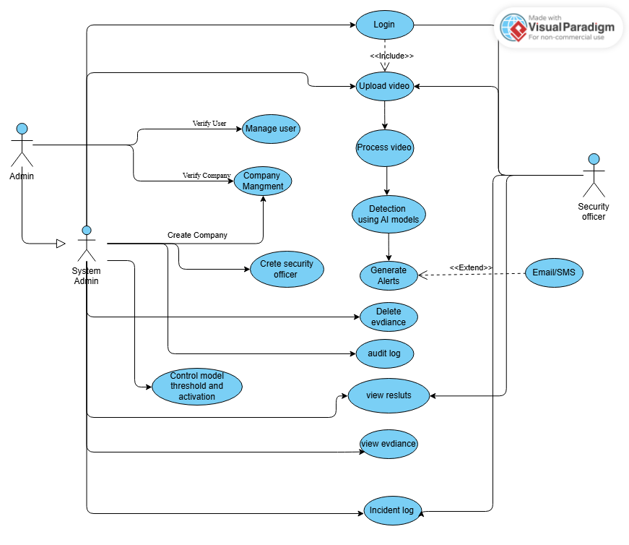
Figure 1: use case diagram with explanation

Extended use cases
Table 5: Extended use case 1
Use Case ID: | UC-1.1
Use Case Name: | User Login
Created By: | M. Amish |  | Last Updated By: | M. Amish
Date Created: | 20-01-2025 |  | Last Revision Date: | 21-01-2025
Actors: |  | Registered User (Admin, Security Officer, Super Admin)
Description: |  | Allows a registered user to authenticate and access the Aegis AI system.
Trigger: |  | User submits login credentials.
Preconditions: |  | - User account exists.  - User account is active.
Post conditions: |  | - User is authenticated successfully.  - System generates an access token.
Normal Flow: |  | - User opens login page.  - User enters username and password.  - System validates credentials.  - System generates authentication token.  - System redirects user to dashboard.
Alternative Flows: |  | 3a. Invalid Credentials  - System displays error message.  - Use case ends.
Exceptions: |  | 2a. Database not reachable  - System displays system unavailable message.
Includes: |  | None
Frequency of Use: |  | High
Special Requirements: |  | Secure authentication using HTTPS.
Assumptions: |  | User has valid login credentials.
Notes and Issues: |  | None

Table 6: Extended use case 2

Use Case ID: |  | UC-1.2
Use Case Name: |  | Upload Pre-Recorded Video
Created By: |  | M. Amish | Last Updated By: | M. Amish
Date Created: |  | 20-01-2025 | Last Revision Date: | 21-01-2025
Actors: | Admins / Security Officer
Description: | Allows users to upload pre-recorded surveillance video / images for AI analysis.
Trigger: | User selects a video / images file for upload.
Preconditions: | - User is logged in.  - Video file is available locally.
Post conditions: | - Video is stored in system.  - Video is queued for analysis.
Normal Flow: | - User selects “Upload Video”.  - System displays file chooser.  - User selects video file.  - System validates file format.  - System uploads video.  - System confirms upload success.
Alternative Flows: | 4a. Unsupported Format  - System displays format error.
Exceptions: | 5a. Upload failure  - System prompts retry.
Includes: | None
Frequency of Use: | Medium
Special Requirements: | Supported formats: MP4, AVI. Png, Jpeg, Jpg
Assumptions: | User uploads valid surveillance footage.
Notes and Issues: | Large files may take time.

Table : Extended use case 3 – UC-1.3: Manage User Accounts and Zone Assignments
Use Case ID: | UC-1.3
Use Case Name: | Manage User Accounts and Zone Assignments
Created By: | M. Amish |  | Last Updated By: | M. Amish
Date Created: | 01-05-2026 |  | Last Revision Date: | 15-05-2026
Actors: | System Administrator, Super Admin
Description: | Allows an administrator to create user accounts, assign roles, and map security officers to surveillance zones via a ZoneOfficerAssignment record.
Trigger: | Administrator navigates to User Management and creates or edits a user.
Preconditions: | Administrator is logged in. At least one zone exists in the system.
Post conditions: | User account created/updated. Zone assignment saved. Incident notifications routed to the assigned officer.
Normal Flow: | 1. Admin opens User Management. 2. Fills in user details (name, email, role, zone). 3. System validates input. 4. Creates/updates user and zone assignment. 5. Confirms success.
Alternative Flows: | 3a. Duplicate email – System displays error "Email already in use." Use case resumes at step 2.
Exceptions: | 3b. Database error – System displays "Could not save user. Try again."
Includes: | UC-1.1 (User Login)
Frequency of Use: | Low
Special Requirements: | Role validation; zone must exist before assignment.
Assumptions: | Admin has Super Admin or Admin privileges.
Notes and Issues: | Zone field is optional; if not assigned, officer receives no zone-specific alerts.

Table 7: Extended use case 4

Use Case ID: | UC-2.1
Use Case Name: | Analyze Video Feed
Created By: | Imaz Khalid |  | Last Updated By: | Imaz Khalid
Date Created: | 21-01-2025 |  | Last Revision Date: | 21-01-2025
Actors: |  | AI Detection Engine
Description: |  | Analyzes uploaded video using AI models.
Trigger: |  | Video upload is completed.
Preconditions: |  | - Video exists in system.  - AI engine is active.
Post conditions: |  | - Detection results are generated.
Normal Flow: |  | - System loads video frames.  - AI processes frames sequentially.  - AI detects objects and activities.  - System stores detection results.
Alternative Flows: |  | 2a. AI Engine Unavailable  - System delays processing.
Exceptions: |  | 1a. Corrupted video  - System marks video invalid.
Includes: |  | UC-2.2, UC-2.3, UC-2.4
Frequency of Use: |  | Medium
Special Requirements: |  | GPU acceleration recommended.
Assumptions: |  | Video quality is sufficient.
Notes and Issues: |  | None

Table 8: Extended use case 5

Use Case ID: | UC-2.2
Use Case Name: | Weapon Detection
Created By: | M. Amish |  | Last Updated By: | M. Amish
Date Created: | 21-01-2025 |  | Last Revision Date: | 21-01-2025
Actors: |  | AI Detection Engine
Description: |  | Detects weapons in uploaded video footage.
Trigger: |  | Video frame analysis begins.
Preconditions: |  | - Video is under analysis.
Post conditions: |  | 1. Weapon detection result is generated.  - Alert is created if weapon detected.
Normal Flow: |  | - AI scans video frame.  - AI detects weapon object.  - System records detection.  - System generates alert.
Alternative Flows: |  | 2a. Low Confidence Detection  - Detection ignored.
Exceptions: |  | None
Includes: |  | UC- 3.1
Frequency of Use: |  | Medium
Special Requirements: |  | Confidence threshold configurable.
Assumptions: |  | Weapon models are trained.
Notes and Issues: |  | False positives possible.

Table 8: Extended use case 5

Use Case ID: | UC-2.2
Username | JWT subject identity
Password | min complexity enforced client/admin policy |  | yes | Stored hashed only (Argon2 preferred)
access_token / refresh_token | JWT |  | yes / yes | Issued via /auth/login & /auth/refresh
integer |  | Scopes queries & FK integrity
integer |  | Links detections/alerts to physical source
string |  | Enables live prototype pipeline when reachable
enum |  | Drives analytics buckets
enum |  | Derived via classify_threat_level + overrides
float |  | Model or heuristic score for alerting policy
float |  | Presentation + audit trail
json |  | e.g., class names, pose/auxiliary metrics
enum |  | Workflow enforcement server-side
boolean |  | SMTP delivery bookkeeping
string |  | Served via /evidence static mount
string |  | generated MP4 job outputs
json |  | Human-readable change summaries for settings

Table 9: Extended use case 5

Use Case ID: | UC-2.3
Use Case Name: | Crowd Detection
Created By: | Alika Jamil |  | Last Updated By: | Alika Jamil
Date Created: | 20-01-2025 |  | Last Revision Date: | 21-01-2025
Actors: |  | AI Detection Engine
Description: |  | Detects overcrowding situations in video footage.
Trigger: |  | Video frame processing.
Preconditions: |  | - Video is being analyzed.
Post conditions: |  | - Crowd count calculated.  - Alert generated if threshold exceeded.
Normal Flow: |  | - AI detects people.  - AI counts individuals.  - System compares threshold.  - System generates alert.
Alternative Flows: |  | 3a. Crowd Below Threshold  - No alert generated.
Exceptions: |  | None
Includes: |  | UC- 3.1
Frequency of Use: |  | Medium
Special Requirements: |  | Threshold configurable.
Assumptions: |  | Angle is appropriate.
Notes and Issues: |  | NoOcclusion may affect accuracy.

Table 10: Extended use case 6

Use Case ID: | UC-2.4
Use Case Name: | Abandoned Object Detection
Created By: | Wajeeha Shehzad |  | Last Updated By: | Wajeeha Shehzad
Date Created: | 20-01-2025 |  | Last Revision Date: | 21-01-2025
Actors: |  | AI Detection Engine
Description: |  | Detects unattended objects in video footage.
Trigger: |  | Object remains static for defined time.
Preconditions: |  | - Video analysis is active.
Post conditions: |  | - Abandoned object alert created.
Normal Flow: |  | - AI detects object.  - AI tracks object over time.  - Object remains unattended.  - System generates alert.
Alternative Flows: |  | 3a. Object Picked Up  1. Detection canceled
Exceptions: |  | None
Includes: |  | UC- 3.1
Frequency of Use: |  | Medium
Special Requirements: |  | Time threshold configurable.
Assumptions: |  | Static cameras used.
Notes and Issues: |  | None

Table : Extended use case 8– UC-2.5: Monitor Live Camera Feed
Use Case ID: | UC-2.5
Use Case Name: | Monitor Live Camera Feed
Created By: | M. Amish |  | Last Updated By: | M. Amish
Date Created: | 01-05-2026 |  | Last Revision Date: | 15-05-2026
Actors: | Security Officer, System Administrator
Description: | Allows security personnel to view a live thumbnail snapshot (refreshed every 5 s) and open a full live stream modal for cameras configured with an RTSP URL. Cameras without an RTSP URL show the last analysis snapshot instead.
Trigger: | User opens Camera Management page or clicks on a camera tile.
Preconditions: | User is authenticated. Camera has a valid stream_url configured.
Post conditions: | Live stream is displayed; AI detection runs on the stream in real time.
Normal Flow: | 1. User opens Camera Management. 2. System fetches live snapshot for each camera with a stream_url. 3. User clicks a camera tile. 4. System opens monitoring modal with live RTSP feed. 5. AI detection results overlay the live feed.
Alternative Flows: | 2a. Camera has no stream_url – System fetches last evidence snapshot from database. 4a. RTSP stream unreachable – Modal shows connection error.
Exceptions: | 2b. No evidence found for offline camera – Placeholder image displayed.
Includes: | UC-2.1 (Analyze Video Feed)
Frequency of Use: | High
Special Requirements: | RTSP-compatible IP camera; FFmpeg installed on server.
Assumptions: | Network connectivity between server and camera is available.
Notes and Issues: | Dual-thread pipeline: frame-reader thread + AI-inference thread for low latency.

Table : Extended use case 9 – UC-2.6: Detect Mask/Face Violations
Use Case ID: | UC-2.6
Use Case Name: | Detect Mask/Face Violations
Created By: | Alika Jamil |  | Last Updated By: | Alika Jamil
Date Created: | 01-05-2026 |  | Last Revision Date: | 15-05-2026
Actors: | System (automated), Security Officer
Description: | Enables the system to automatically detect individuals not wearing face masks in video frames using a YOLOv8-based mask/face detection model.
Trigger: | Video frame arrives for processing (uploaded video or live stream).
Preconditions: | Mask/face detection module is enabled. Confidence threshold is configured.
Post conditions: | Violation detected; evidence snapshot saved; alert generated if threshold met.
Normal Flow: | 1. System receives a video frame. 2. Mask detection model processes the frame. 3. Model identifies faces without masks above confidence threshold. 4. System saves evidence snapshot. 5. System generates alert and sends notification.
Alternative Flows: | 3a. Confidence below threshold – Detection discarded; no alert generated.
Exceptions: | 2a. Model not loaded – System logs error and skips frame.
Includes: | UC-2.1, Receive Alert Notification
Frequency of Use: | High (continuous during active detection)
Special Requirements: | Mask/face detection YOLOv8 model weights must be present.
Assumptions: | Module is enabled in detection settings.
Notes and Issues: | Detection result includes bounding box, confidence score, and class label.

Table 11: Extended use case 7

Use Case ID: | UC-3.1
Use Case Name: | Review and Resolve Incident
Created By: | Alika Jamil |  | Last Updated By: | Alika Jamil
Date Created: | 20-01-2025 |  | Last Revision Date: | 21-01-2025
Actors: |  | Primary Actor: Security Officer  Secondary Actor: Admin
Description: |  | Allows users to review alerts and close incidents.
Trigger: |  | System generates alert.
Preconditions: |  | - Incident exists.
Post conditions: |  | - Incident marked resolved or false positive.
Normal Flow: |  | - User opens incident list.  - User selects incident.  - System displays details.  - User marks incident resolved.  - System saves status.
Alternative Flows: |  | 4a. False Positive  - User marks false positive.
Exceptions: |  | None
Includes: |  | None
Frequency of Use: |  | Medium
Special Requirements: |  | Audit logging required.
Assumptions: |  | User has authority.
Notes and Issues: |  | None

Table : Extended use case 11 – UC-3.2: Acknowledge Incident
Use Case ID: | UC-3.2
Use Case Name: | Acknowledge Incident
Created By: | Alika Jamil |  | Last Updated By: | Alika Jamil
Date Created: | 01-05-2026 |  | Last Revision Date: | 15-05-2026
Actors: | Security Officer, System Administrator
Description: | Allows a security officer or administrator to acknowledge a detected alert, changing its status to ACKNOWLEDGED and recording the officer's username and acknowledgment timestamp.
Trigger: | User clicks "Acknowledge" on an open incident in the Incidents table.
Preconditions: | User is authenticated. Alert is in OPEN or PENDING status.
Post conditions: | Alert status set to ACKNOWLEDGED. acknowledged_by and acknowledged_at fields populated. Incidents table shows updated status badge with actor name.
Normal Flow: | 1. User opens Incidents page. 2. Clicks Acknowledge on a target alert. 3. System sends PATCH /alerts/{id} with status=ACKNOWLEDGED. 4. Backend records username and timestamp. 5. Frontend re-fetches full alert detail and updates the table row.
Alternative Flows: | 3a. Network error – UI shows error toast; status reverts.
Exceptions: | 3b. Alert already acknowledged – System returns 409 conflict.
Includes: | None
Frequency of Use: | Medium
Special Requirements: | User must have Officer or Admin role.
Assumptions: | Alert exists and is visible to the current user based on company scope.
Notes and Issues: | "Acknowledged by <username> at <timestamp>" displayed below status badge.

Table : Extended use case 12 – UC-3.3: Resolve Incident
Use Case ID: | UC-3.3
Use Case Name: | Resolve Incident
Created By: | Wajeeha Shehzad |  | Last Updated By: | Wajeeha Shehzad
Date Created: | 01-05-2026 |  | Last Revision Date: | 15-05-2026
Actors: | Security Officer, System Administrator
Description: | Allows an authorized user to mark an incident as RESOLVED, recording the resolver's username (resolved_by) and the resolution timestamp (resolved_at).
Trigger: | User selects "Resolve" from the status dropdown in the Incidents table.
Preconditions: | User is authenticated. Alert is in ACKNOWLEDGED or OPEN status.
Post conditions: | Alert status set to RESOLVED. resolved_by and resolved_at populated. Incidents table shows "Resolved by <username>" below status badge.
Normal Flow: | 1. User selects "Resolve" from the action dropdown. 2. System sends PATCH /alerts/{id} with status=RESOLVED. 3. Backend sets resolved_by = current_user.username, resolved_at = now(). 4. Frontend re-fetches full alert and updates UI.
Alternative Flows: | 3a. Network error – UI shows error toast.
Exceptions: | 3b. Alert already resolved – System returns 409 conflict.
Includes: | UC-3.2 (Acknowledge Incident)
Frequency of Use: | Medium
Special Requirements: | User must have Officer or Admin role.
Assumptions: | Alert was previously acknowledged.
Notes and Issues: | resolved_by and resolved_at stored in alerts table as nullable columns.

Table : Extended use case 13 – UC-3.4: Mark Incident as False Positive
Use Case ID: | UC-3.4
Use Case Name: | Mark Incident as False Positive
Created By: | M. Amish |  | Last Updated By: | M. Amish
Date Created: | 01-05-2026 |  | Last Revision Date: | 15-05-2026
Actors: | Security Officer, System Administrator
Description: | Allows an authorized user to dismiss a detected alert as a FALSE_POSITIVE, recording the dismissing user's username and timestamp.
Trigger: | User selects "False Positive" from the action dropdown.
Preconditions: | User is authenticated. Alert is in OPEN or ACKNOWLEDGED status.
Post conditions: | Alert status set to FALSE_POSITIVE. false_positive_by and false_positive_at populated.
Normal Flow: | 1. User selects "False Positive" action. 2. System sends PATCH /alerts/{id} with status=FALSE_POSITIVE. 3. Backend records false_positive_by and false_positive_at. 4. UI refreshes the row.
Alternative Flows: | 3a. Network error – UI shows error toast.
Exceptions: | None
Includes: | None
Frequency of Use: | Low
Special Requirements: | User must have Officer or Admin role.
Assumptions: | Alert was incorrectly triggered by the AI model.
Notes and Issues: | Helps measure and improve model accuracy over time.

Table : Extended use case 14 – UC-4.1: Configure Detection Settings
Use Case ID: | UC-4.1
Use Case Name: | Configure Detection Settings
Created By: | M. Amish |  | Last Updated By: | M. Amish
Date Created: | 01-05-2026 |  | Last Revision Date: | 15-05-2026
Actors: | System Administrator, Super Admin
Description: | Allows an administrator to configure per-module AI detection settings including enable/disable toggle, confidence thresholds (low/medium/high/critical), alert trigger levels, and abandoned-object timeout.
Trigger: | Admin navigates to System Settings > Detection Settings.
Preconditions: | User is authenticated as Admin or Super Admin.
Post conditions: | Updated settings saved to database. Audit log entry created showing only the changed fields. Detection pipeline uses new settings within 60 seconds (cache TTL).
Normal Flow: | 1. Admin opens Detection Settings. 2. System loads current settings for each AI module. 3. Admin modifies desired fields and saves. 4. System diffs old vs new values. 5. Saves changes and writes audit log with changed fields only. 6. Success notification displayed.
Alternative Flows: | 3a. No changes made – System skips saving and shows "No changes detected."
Exceptions: | 5a. Database error – Changes not saved; error returned.
Includes: | None
Frequency of Use: | Low
Special Requirements: | Admin-level access required.
Assumptions: | Detection modules are installed and model weights are available.
Notes and Issues: | Audit log uses FRIENDLY label map for human-readable field names.

Table : Extended use case 15 – UC-4.2: View Analytics Dashboard
Use Case ID: | UC-4.2
Use Case Name: | View Analytics Dashboard
Created By: | Alika Jamil |  | Last Updated By: | Alika Jamil
Date Created: | 01-05-2026 |  | Last Revision Date: | 15-05-2026
Actors: | Security Officer, System Administrator, Facility Management
Description: | Allows users to view a multi-chart analytics dashboard including incident timeline, threat-type distribution, zone-based incident counts, top cameras by incident volume, and a time-of-day heatmap.
Trigger: | User navigates to the Analytics page.
Preconditions: | User is authenticated. At least one alert exists in the database.
Post conditions: | All charts rendered with current data.
Normal Flow: | 1. User opens Analytics page. 2. System calls /analytics/all endpoint. 3. Backend executes all aggregation queries in one session. 4. Frontend receives combined JSON and renders each chart.
Alternative Flows: | 2a. No data – Charts display "No data available" placeholder.
Exceptions: | 2b. API error – Error message shown; charts show empty state.
Includes: | None
Frequency of Use: | Medium
Special Requirements: | PostgreSQL aggregation queries with GROUP BY.
Assumptions: | Detection has been running and alerts exist.
Notes and Issues: | Heatmap uses SQL-level aggregation (SUM+CASE) for performance.

Table : Extended use case 16 – UC-4.3: Receive Zone-Based Alert Notification
Use Case ID: | UC-4.3
Use Case Name: | Receive Zone-Based Alert Notification
Created By: | Wajeeha Shehzad |  | Last Updated By: | Wajeeha Shehzad
Date Created: | 01-05-2026 |  | Last Revision Date: | 15-05-2026
Actors: | Security Officer (recipient), System (sender)
Description: | The system automatically sends an email notification to the security officer assigned to the zone where a detected incident occurred. Only officers whose assigned zone matches the incident zone receive the email.
Trigger: | System generates an alert above the configured threshold for a zone.
Preconditions: | At least one security officer is assigned to the zone. SMTP email service is configured. Alert exceeds notification threshold.
Post conditions: | Email sent to zone-assigned officer(s) with incident details and snapshot link.
Normal Flow: | 1. System detects a threat above threshold. 2. System identifies the camera's zone. 3. Queries ZoneOfficerAssignment for officers in that zone. 4. Composes email with incident details. 5. Sends email via aiosmtplib.
Alternative Flows: | 3a. No officer assigned to zone – Notification sent to company admin instead.
Exceptions: | 5a. SMTP failure – Error logged; notification marked as failed.
Includes: | Receive Alert Notification
Frequency of Use: | High (triggered per detection event above threshold)
Special Requirements: | SMTP credentials configured in system settings.
Assumptions: | Zone field is set on both camera and officer assignment.
Notes and Issues: | Uses aiosmtplib for async email delivery to avoid blocking the detection pipeline.

User interfaces (mock screens)

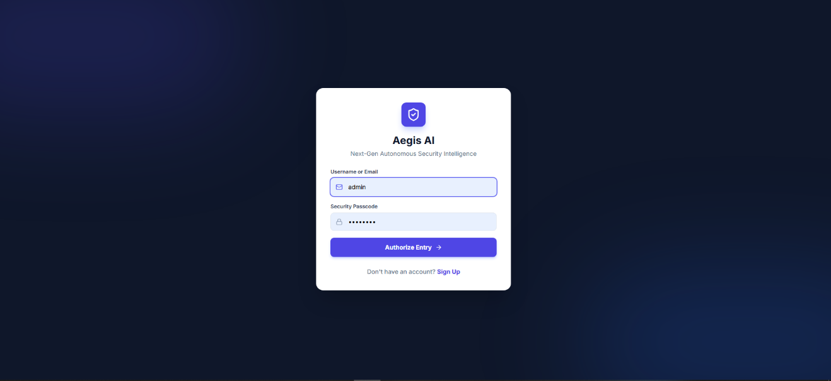
Figure 2: Prototype1 Login Screen

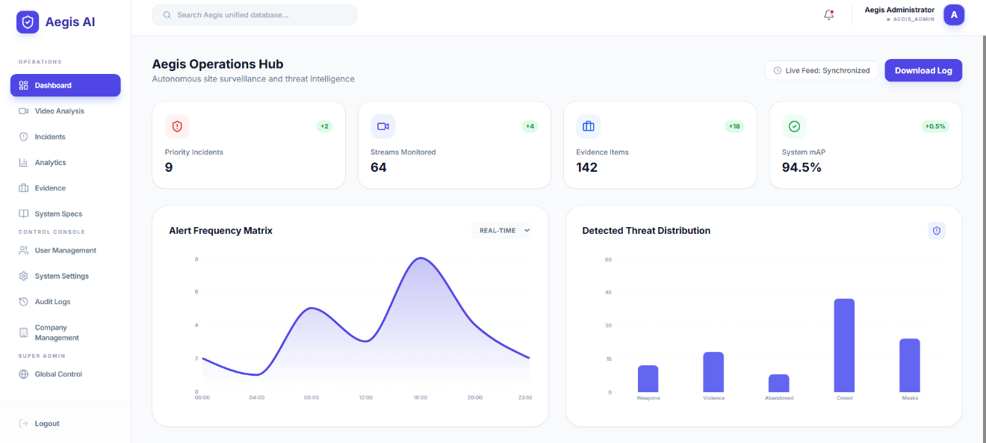
Figure 3: Prototype2 Aegis Admin Dashboard Screen

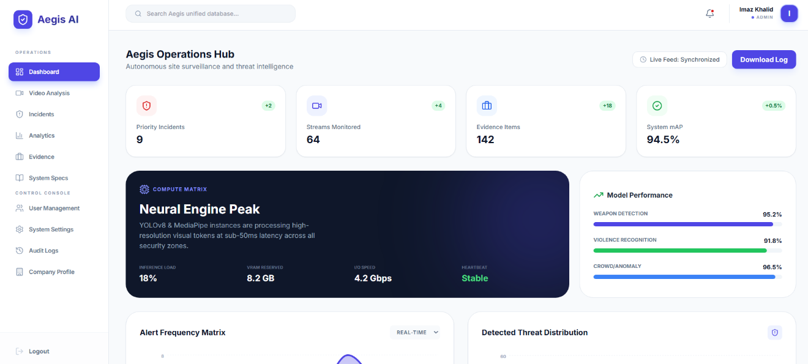
Figure 4: Prototype3: Company Admin Dashboard Screen

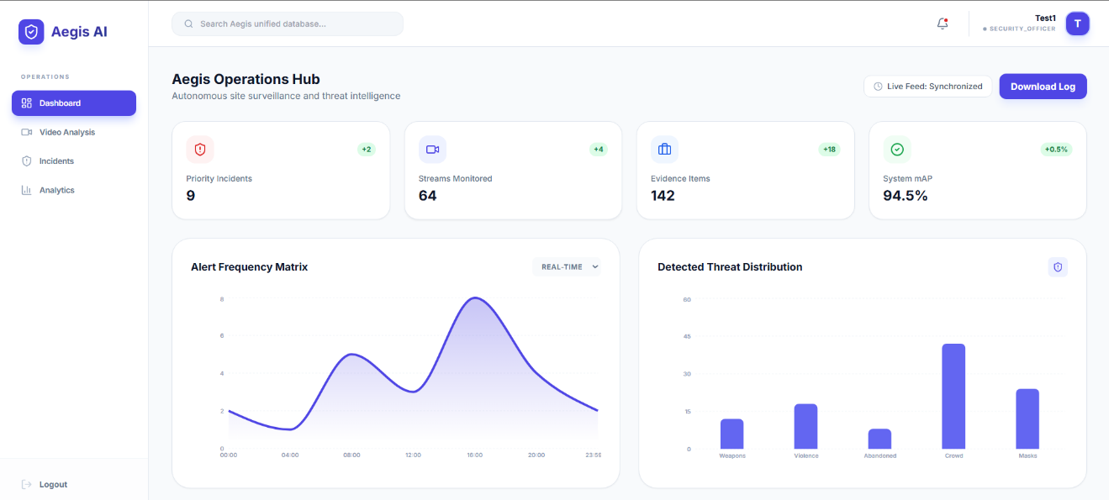
Figure 5: Prototype4 Security Officer Screen

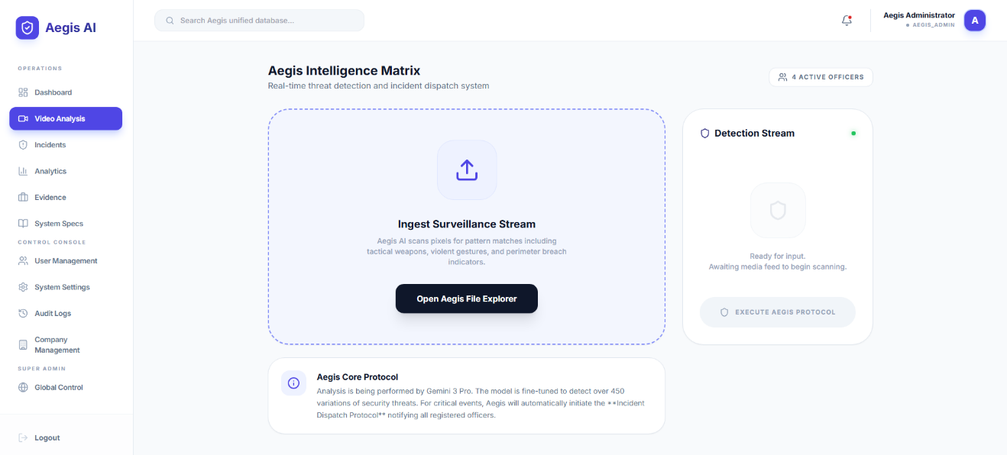
Figure 6: Prototype5 Vedio Upload Screen

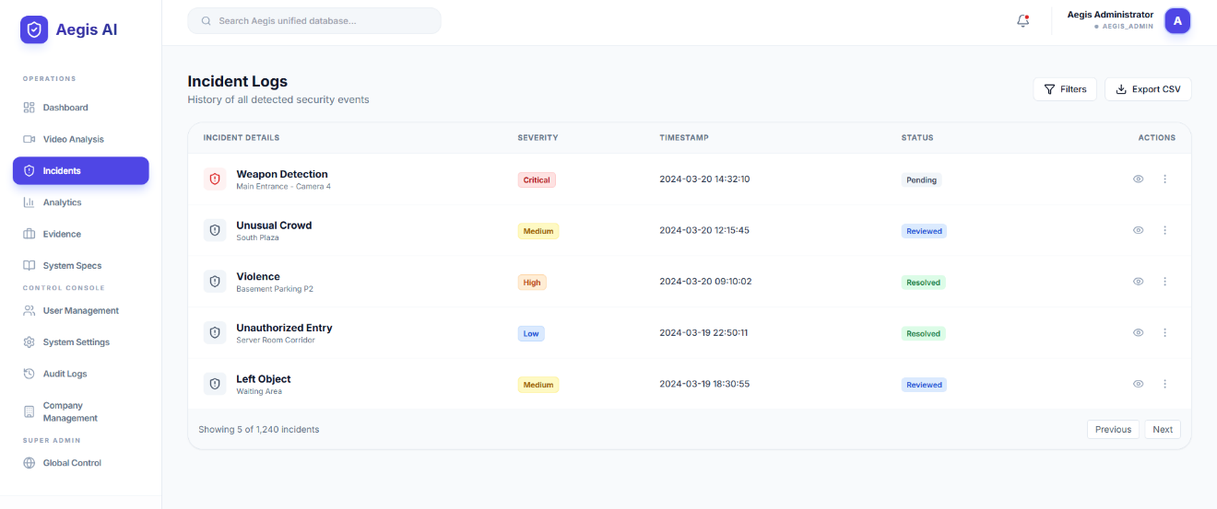
Figure 7: Prototype6 Incident Log Screen

Data flow diagram (optional)

Data Flow Diagram Level 0

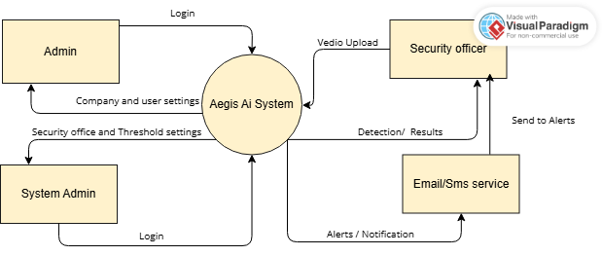
Figure 8: Level 0 DFD of Aegis AI

System Design

System Architecture Diagram
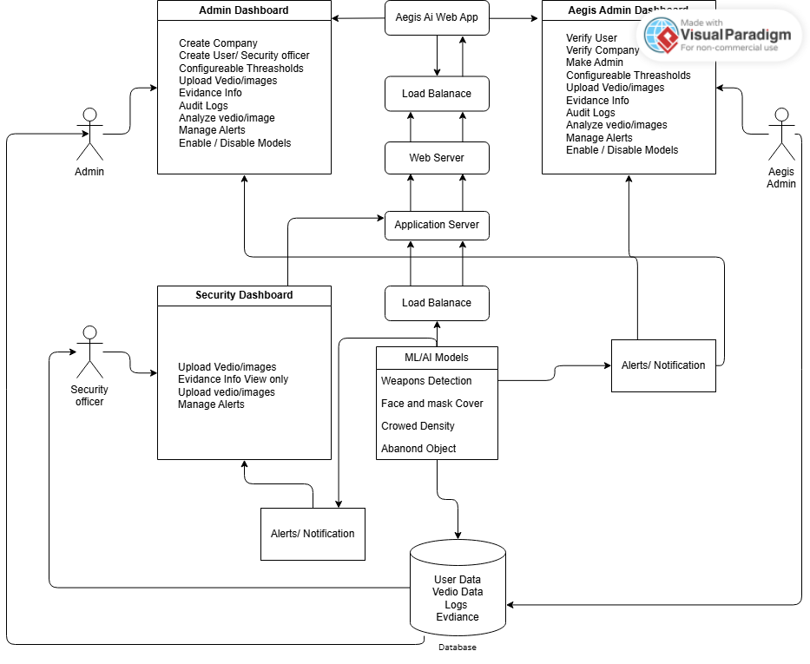
Figure 9: System Architecture

Class Diagram

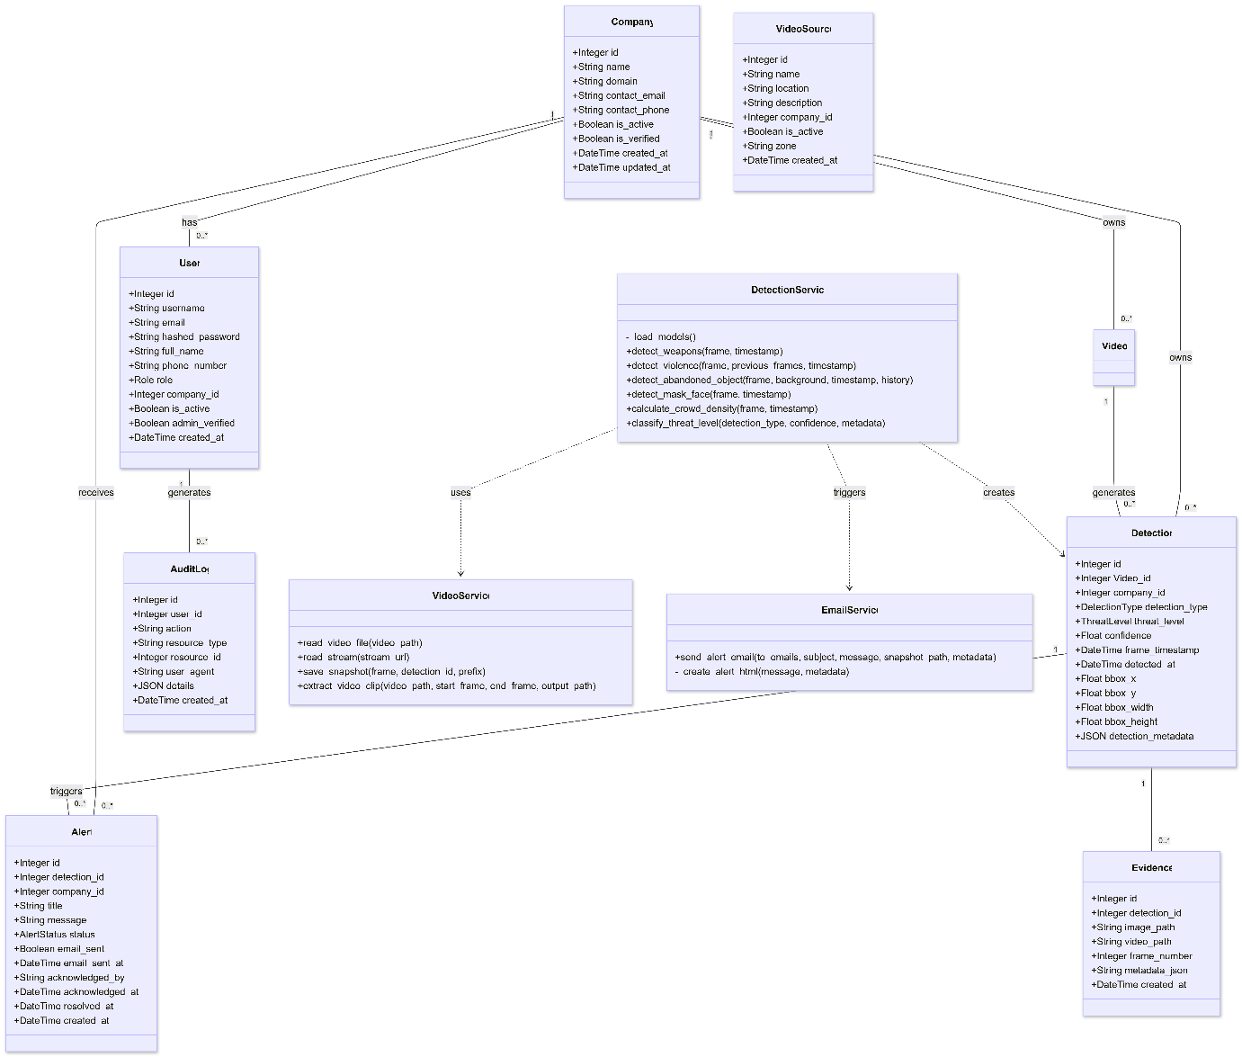
Figure 10: Class Diagram of Aegis AI

Sequence Diagrams
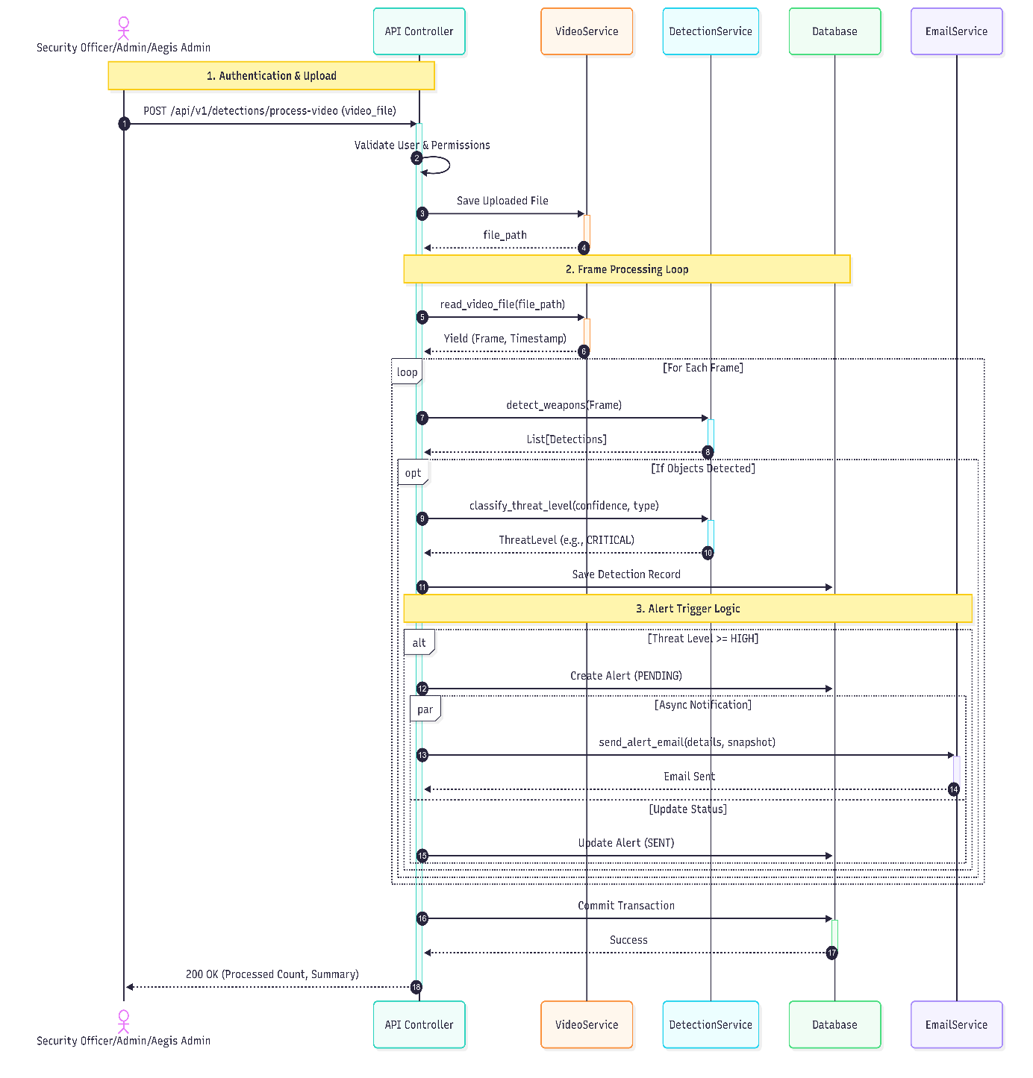
Figure 11: Sequence Diagram of Aegis AI

Collaboration Diagrams
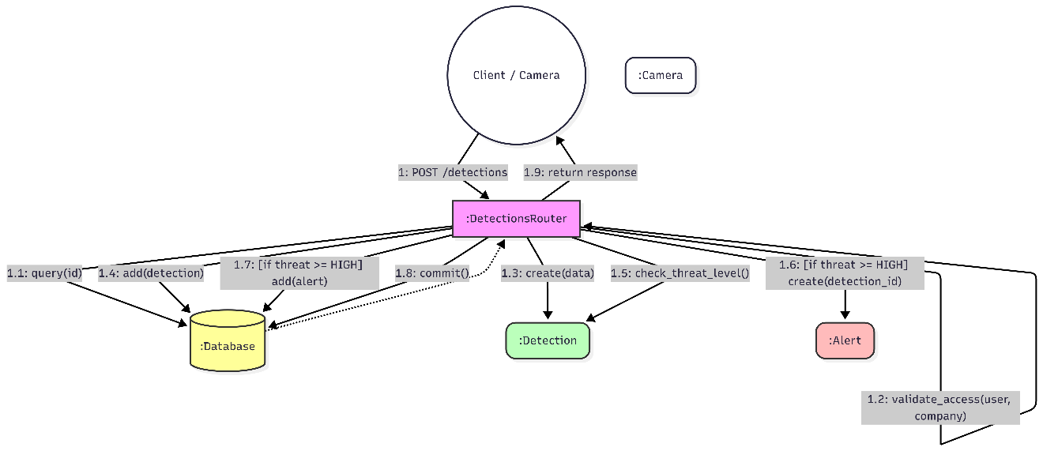
Figure 12: Collaboration Diagram of Aegis Ai

ERD
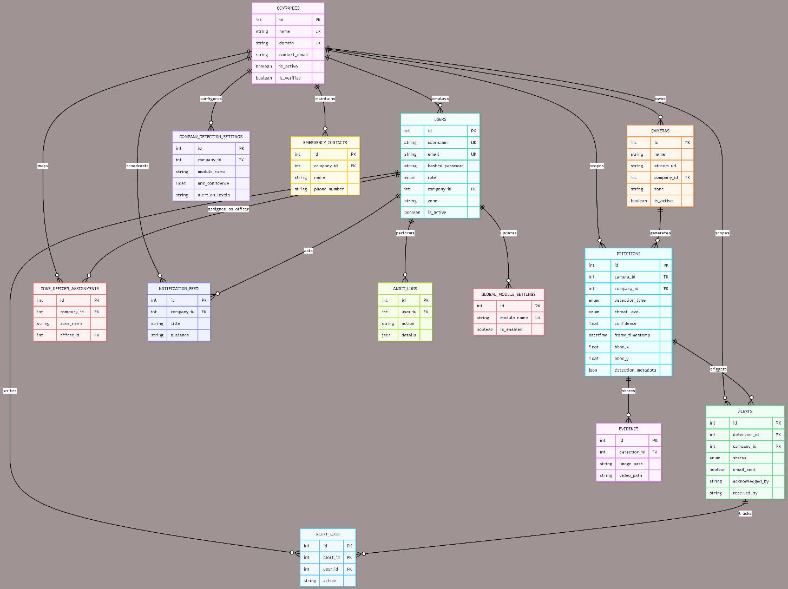
Figure 13: ER Daigram

Data Dictionary
This section defines the key interface elements, data inputs, validation rules, and system outputs used in the Aegis AI Smart Security Surveillance System. It covers authentication fields, upload/live inputs, AI detection outputs, alert lifecycle data, evidence storage, and dashboard analytics filters.
Table 12: Data Dictionary Table
Element Name | Type | Validation | Mandatory | Remarks
Username | String | Alphanumeric, min 4 characters | Yes | Primary login identifier
Email | String | Valid email format | Yes | Used for login, alerts, and verification
Password | String | Min 8 characters, masked input | Yes | Stored hashed (Argon2/bcrypt); never plain text
Role | Enum | aegis_admin | admin | security_officer | viewer | Yes | Controls RBAC permissions
Company ID | Integer | Valid company FK | Yes | Tenant isolation scope for all queries
JWT Access Token | String | Signed token, short expiry | Yes | API authentication after login
JWT Refresh Token | String | Signed token, longer expiry | Yes | Renews access token securely
Zone Assignment | String | Existing zone name | No | Maps security officer to camera zone
Video Upload | File | MP4, AVI formats | Yes | Primary input for offline AI analysis
Image Upload | File | JPG, PNG formats | No | Optional image-based detection input
RTSP Stream URL (Prototype) | String | Valid RTSP/HTTP URL | No | Prototype live-camera input only
Camera Name | String | Max 100 characters | Yes | Identifies camera source in UI and reports
Camera Zone | String | Max 100 characters | No | Groups cameras for analytics and alert routing
Video Processing Job ID | UUID/String | System-generated | Yes | Tracks async upload processing status
Detection Module Toggle | Boolean | Enabled / Disabled | Yes | Per-company module enablement
Confidence Threshold | Float | 0.0 – 1.0 | Yes | Minimum model confidence to accept detection
Weapon Detection Output | Boolean | True / False | Yes | Indicates weapon/bag/box presence
Violence Detection Output | Boolean | True / False | Yes | Conv3D classifier result
Mask/Face Violation Output | Boolean | True / False | Yes | YOLOv8 face-obfuscation result
Abandoned Object Flag | Boolean | True / False | Yes | Object stationary beyond threshold
Crowd Density Count | Integer | ≥ 0 | Yes | Estimated people count from SANet/CSRNet
Threat Level | Enum | low | medium | high | critical | Yes | Derived from confidence and module rules
Detection Type | Enum | weapon | violence | abandoned_object | mask_face | crowd_density | Yes | Classification of AI result
Detection Confidence Score | Float | 0.0 – 1.0 | Yes | Raw model confidence value
Bounding Box Coordinates | Float[4] | Normalized 0.0 – 1.0 | No | bbox_x, bbox_y, bbox_width, bbox_height
Frame Timestamp | DateTime | ISO-8601 | Yes | Time of frame in source video/stream
Alert Message | String | Auto-generated | Yes | Human-readable threat summary
Alert Status | Enum | pending | sent | acknowledged | resolved | false_positive | Yes | Incident lifecycle state
Alert Timestamp | DateTime | System-generated | Yes | Time alert was created
Email Sent Flag | Boolean | True / False | Yes | SMTP delivery status
SMS Sent Flag | Boolean | True / False | No | Twilio delivery status
Acknowledged By | String | Username | No | Officer who acknowledged alert
Resolved By | String | Username | No | User who resolved incident
Detection ID | Integer | Auto-increment PK | Yes | Unique detection record identifier
Evidence Image Path | String | Valid file path | Yes | Snapshot stored on disk/cloud volume
Evidence Video Path | String | Valid file path | No | Optional short clip path
Detection Metadata JSON | JSON | Valid JSON object | No | Extra model output (class, counts, etc.)
Audit Log Entry | JSON/Text | System-generated | Yes | User action, IP, resource, timestamp
Analytics Date Range | DateRange | Start ≤ End | No | Filters dashboard charts
Zone Filter | String | Existing zone | No | Filters analytics by camera zone

Implementation details

Development Setup
This section describes the tools, technologies, and environments used during the development of the Aegis AI Surveillance System and their respective roles.
Hardware Requirements
- Processor: Multi-core x86_64 cloud VM (AWS EC2 / Google Compute Engine)
- GPU: NVIDIA Tesla P100 with CUDA support for AI inference acceleration
- RAM: Minimum 16 GB (32 GB recommended for concurrent video jobs)
- Storage: SSD or cloud block storage for uploads, evidence, and model weights
- Operating System: Ubuntu Linux (20.04/22.04 LTS)
- Input: Uploaded MP4/AVI video files (primary); prototype RTSP/HTTP camera streams
Tool / Technology | Role in Development
Python 3.11+ | Core backend language and AI pipeline orchestration
FastAPI | REST API for auth, uploads, detections, alerts, and analytics
React | Web dashboard UI (incidents, cameras, analytics, settings)
YOLOv8 (Ultralytics) | Weapon, bag/box, and mask/face detection
SANet/CSRNet (ONNX) | Crowd density estimation and heatmap generation
Conv3D Violence Model | Temporal violence classification on frame windows
OpenCV | Video frame extraction, RTSP I/O, preprocessing, visualization
PyTorch | Training and PyTorch-weight inference where applicable
ONNX Runtime | GPU/CPU optimized inference for crowd and violence models
PostgreSQL 15+ | Relational storage for tenants, detections, alerts, audit logs
Redis 7+ | Caching and background job coordination
SQLAlchemy + Alembic | ORM models and database migrations
JWT + Argon2/bcrypt | Authentication and secure password hashing
SMTP + Twilio | Email and SMS alert delivery
Docker / docker-compose | Containerized deployment on cloud GPU VMs
AWS EC2 / Google Cloud GPU VM | Cloud deployment on Ubuntu with P100 GPU
Git & GitHub | Version control and collaboration
VS Code | Primary development IDE

Deployment setup

Deployment Environment
The system is deployed on cloud GPU virtual machines using AWS EC2 and Google Cloud Platform (Compute Engine).
- Application Server: Ubuntu Linux VM with NVIDIA Tesla P100 GPU and CUDA drivers.
- Backend API: FastAPI service running on the GPU-enabled Ubuntu instance.
- AI Models: YOLOv8, SANet/CSRNet ONNX, and Conv3D weights executed on P100 GPU (CPU fallback via ONNX when needed).
- Database: PostgreSQL hosted on cloud VM or managed database service.
- Cache/Queue: Redis for session cache and background processing coordination.
- Prototype Live Stream: RTSP ingestion runs on the same Ubuntu GPU worker (experimental scope).
- Alert Services: SMTP email and Twilio SMS configured through environment variables.
- Storage: Cloud block storage / mounted volumes for uploads, evidence snapshots, and processed outputs.
- Frontend: React dashboard accessed via HTTPS through cloud public IP or load balancer.

Deployment Architecture
- User accesses the React web dashboard via browser over HTTPS.
- Frontend sends authenticated REST requests to the FastAPI backend on AWS/GCP Ubuntu VM.
- User uploads video or registers camera stream URL (prototype RTSP).
- Uploaded videos and evidence files are stored on cloud-attached storage.
- Background workers on the P100 GPU VM extract frames with OpenCV.
- Enabled AI modules run inference and persist detections to PostgreSQL.
- Alert engine evaluates threat level, zone assignment, and company notification settings.
- Email/SMS notifications are sent to assigned security officers and admins.
- Dashboard and analytics endpoints read company-scoped data for visualization.

Table 14: Challenges Faced & Solutions
Problem | Solution
Large video file size | Frame subsampling, resolution scaling, and async background jobs
GPU memory limits on P100 | Optimized input sizes, ONNX models, and batch control
Slow CPU-only inference | ONNX Runtime + CUDA on P100; configurable inference FPS
Alert spamming | Confidence thresholds, threat-level filters, and company module settings
Multi-tenant data leakage risk | Company-scoped queries and RBAC on every API endpoint
RTSP stream instability (prototype) | Buffered capture, reconnect logic, and reduced process FPS
Database growth from evidence | Configurable DATA_RETENTION_DAYS auto-cleanup policy

Algorithms

Video Frame Processing Algorithm
- Purpose: Efficiently extract and route frames from uploaded videos and prototype live streams.
- Load video file with OpenCV or open RTSP/HTTP stream (prototype).
- For uploads: iterate frames at configurable analysis rate.
- For live prototype: dedicated reader thread publishes latest frame; inference thread runs at process_fps.
- Resize frames to model input dimensions (e.g., 640px max side for YOLO).
- Forward frames to enabled detection modules in the processing pipeline.

Weapon Detection Algorithm
- Purpose: Detect weapons, bags, and boxes in surveillance footage.
- Uses YOLOv8 fine-tuned weights (weapon_detection model).
- Detections with confidence ≥ configured threshold are accepted.
- Threat level mapped from confidence and company module settings.
- Each detection is logged with timestamp, bbox, camera_id, and company_id.

Crowd Detection Algorithm
- Purpose: Estimate crowd density and identify overcrowded areas.
- Run SANet/CSRNet ONNX density map on resized frame.
- Apply peak-ratio and coefficient-of-variation filters to reduce false positives.
- Calibrate estimated count using YOLO person count where enabled.
- Generate people count, threat level, and optional heatmap overlay.
- Persist crowd detection when count exceeds configured minimum threshold.

Abandoned Object Detection Algorithm
- Purpose: Detect unattended bags/boxes in video footage.
- Detect static bag/box classes using YOLOv8 across consecutive frames.
- Track object persistence and position stability over time.
- If object remains stationary beyond abandoned_seconds threshold → mark as abandoned.
- Create detection record and trigger alert workflow if threat level qualifies.

Alert Generation Algorithm
Purpose: Notify relevant personnel.
Steps:
- Receive detection results.
- Verify confidence level.
- Log incident in database.
- Trigger Email/SMS alert to security officer.

Live Stream Processing Algorithm (Prototype)
- Purpose: Prototype pipeline for RTSP/HTTP camera preview and background AI inference.
- Open stream with OpenCV FFmpeg backend and low-latency buffer settings.
- Reader thread captures frames at camera FPS and publishes latest preview frame.
- Inference thread pulls latest frame at configurable process_fps.
- Run enabled modules and persist detections/alerts same as upload pipeline.
- Prototype scope: reliability depends on network stability and camera codec support.

Mask/Face Violation Detection Algorithm
- Purpose: Detect uncovered or improperly covered faces for compliance monitoring.
- Uses YOLOv8 face/mask detection weights on each analyzed frame.
- Filter detections below company min_confidence threshold.
- Map detections to threat levels based on company module settings.
- Store bbox, confidence, and optional privacy-blurred evidence snapshot.

Violence Detection Algorithm
- Purpose: Detect violent or aggressive behavior using temporal video analysis.
- Maintain sliding window of recent analyzed frames (≈2–3.5 seconds).
- Sample/subselect frames to form 16-frame clip for Conv3D model.
- Run Conv3D ONNX/PyTorch classifier; read P(violence) softmax score.
- If probability ≥ threshold, create violence detection with confidence and threat level.

Constraints

Assumptions
The system development is based on the following assumptions:
Users will have valid login credentials issued by a company admin or Aegis platform admin.
Surveillance videos are clear and usable for AI analysis.
Cameras are placed at appropriate angles with adequate lighting conditions.
The client is responsible for routine database maintenance and backup.
Internet connectivity is available for Email/SMS alert delivery.
For prototype live streaming, RTSP camera streams are reachable from the application server network.
The system is not integrated with external law enforcement systems.

System Constraints
System constraints define how the system must operate or be built.
Primary processing mode is uploaded video; live RTSP is a prototype with reduced reliability guarantees.
GPU recommended for real-time inference; CPU supported with reduced throughput via ONNX.
Requires stable internet connectivity for Email/SMS alert delivery.
Model accuracy depends on training dataset quality and scene conditions.
Local storage capacity limits evidence and processed-video retention duration.
Multi-tenant data isolation enforced at the API layer for all company-scoped resources.

Restrictions
Restrictions imposed by the client or project scope:
No facial identity recognition (only face-obfuscation/mask detection).
Live RTSP stream processing is prototype only (video upload is the primary supported input).
Alerts limited to Email (SMTP) and SMS (Twilio) channels only.
System access restricted to four roles: aegis_admin, admin, security_officer, and viewer.
Deployment limited to on-premise or Docker-based environments.

Limitations
The system is unable to provide the following services:
- 100% detection accuracy in all environments.
- Detection in extremely low-light or blurred footage.
- Automatic law enforcement reporting.
- Behavioral prediction beyond detected events.
- Offline alert notifications without internet connectivity.

Testing

Extended Test Cases

Table 15: Extended Test Case1
Test Case ID: TC-01 |  |  |  | Test Design By: Aegis AI Team
Test Module Name: User Authentication (Login Module) |  |  |  | Test Design Date: 20/01/2026
Test Title/Name: User Authentication |  |  |  | Test Executed By: Aegis AI Team
Test Title/Objective: To test user login functionality |  |  |  | Test Executed Date: 20/01/2026
Description: This test case verifies that a registered user can successfully log into the system using valid credentials.
Pre-Condition: User must be registered in the system and have valid login credentials.
Dependencies: Active internet connection and authentication service.
Step | Test Step | Test Date | Expected Result | Actual Result | Status (Pass/Fail) | Notes
1 | Open the login page | 10-01-2026 | Login page loads | Login page loads | Pass | Page loaded successfully
2 | Enter valid username | 10-01-2026 | Username accepted | Username accepted | Pass | Valid input
3 | Enter valid password | 10-01-2026 | Password accepted | Password accepted | Pass | No validation error
4 | Click Login button | 10-01-2026 | Dashboard displayed | Dashboard displayed | Pass | Login successful
Post Condition: User session is created and dashboard is displayed.

Table 16: Extended Test Case 2

Test Case ID: TC-02 |  |  |  | Test Design By: Aegis AI Team
Test Module Name: Video Upload Module |  |  |  | Test Design Date: 21/01/2026
Test Title/Name: User Authentication |  |  |  | Test Executed By: Aegis AI Team
Test Title/Name: Pre-Recorded Video Upload |  |  |  | Test Executed Date: 21/01/2026
Description: This test case verifies that the system allows users to upload pre-recorded video files successfully.
Pre-Condition: User must be registered in the system and have valid login credentials.
Dependencies: Active internet connection and authentication service. File system access and video upload service.
Step | Test Step | Test Date | Expected Result | Actual Result | Status (Pass/Fail) | Notes
1 | Login to system | 10-01-2026 | User logged in | Login page loads | Pass | Auth success
2 | Select upload video option | 10-01-2026 | Upload form opens | Username accepted | Pass | UI loaded
3 | Choose video file | 10-01-2026 | File selected | Password accepted | Pass | Supported format
4 | Click upload button | 10-01-2026 | Dashboard displayed | Video uploaded | Pass | Upload complete
Post Condition: Video is stored and ready for processing.

Table 17: Extended Test Case 3

Test Case ID: TC-03 |  |  |  | Test Design By: Aegis AI Team
Test Module Name: AI Threat Detection Module |  |  |  | Test Design Date: 10/01/2026
Test Title/Name: AI Detection on Pre-Recorded Video |  |  |  | Test Executed By: Aegis AI Team
Test Title/Objective: To test AI-based detection on uploaded video. |  |  |  | Test Executed Date: 10/01/2026
Description: This test case verifies that AI models correctly detect threats such as weapons, crowd gathering, or abandoned objects from pre-recorded video.
Pre-Condition: A pre-recorded video must be uploaded successfully.
Dependencies: AI detection models and processing server.
Step | Test Step | Test Date | Expected Result | Actual Result | Status (Pass/Fail) | Notes
1 | Start video processing | 10-01-2026 | Processing begins | Processing begins | Pass | Server active
2 | Analyze video frames | 10-01-2026 | Frames analyzed | Frames analyzed | Pass | Smooth processing
3 | Detect threat | 10-01-2026 | Threat detected | Threat detected | Pass | Accurate result
4 | Store detection | 10-01-2026 | Data stored | Data stored | Pass | DB updated
Post Condition: Detected threats are stored and forwarded to alert module.

Table 18: Extended Test Case 4

Test Case ID: TC-04 |  |  |  | Test Design By: Aegis AI Team
Test Module Name: Alert & Notification Module |  |  |  | Test Design Date: 10/01/2026
Test Title/Name: Alert Generation |  |  |  | Test Executed By: Aegis AI Team
Test Title/Objective: To test alert and notification functionality. |  |  |  | Test Executed Date: 10/01/2026
Description: This test case verifies that alerts are generated and notifications are sent when a threat is detected.
Pre-Condition: A valid threat must be detected by the AI system.
Dependencies: Alert engine, email/SMS service.
Step | Test Step | Test Date | Expected Result | Actual Result | Status (Pass/Fail) | Notes
1 | Threat detected | 10-01-2026 | Threat confirmed | Threat confirmed | Pass | AI output
2 | Generate alert | 10-01-2026 | Alert created | Alert created | Pass | Rule matched
3 | Send notification | 10-01-2026 | Alert delivered | Alert delivered | Pass | Email/SMS
4 | Log alert | 10-01-2026 | Alert stored | Alert stored | Pass | Saved
Post Condition: Authorized users receive alert notification.

Table 19: Extended Test Case 5

Test Case ID: TC-05 |  |  |  | Test Design By: Aegis AI Team
Test Module Name: Incident Reporting Module |  |  |  | Test Design Date: 10/01/2026
Test Title/Name: Incident Report Viewing |  |  |  | Test Executed By: Aegis AI Team
Test Title/Objective: To test viewing of incident reports. |  |  |  | Test Executed Date: 10/01/2026
Description: This test case verifies that users can view generated incident reports.
Pre-Condition: User must be logged in and reports must exist.
Dependencies: Database and reporting module.
Step | Test Step | Test Date | Expected Result | Actual Result | Status (Pass/Fail) | Notes
1 | Login to system | 10-01-2026 | User logged in | User logged in | Pass | Access OK
2 | Open incident log | 10-01-2026 | Reports shown | Reports shown | Pass | Loaded
3 | Select report | 10-01-2026 | Report opens | Report opens | Pass | Correct
4 | View details | 10-01-2026 | Details visible | Details visible | Pass | Verified
Post Condition: Incident report details are displayed correctly.

Table : Extended Test Case – TC-06: Live Camera Feed Display
Test Case ID: TC-06 |  |  |  | Test Design By: Aegis AI Team
Test Module Name: Live Stream Monitoring Module |  |  |  | Test Design Date: 15-05-2026
Test Title/Name: Live Camera Feed Display |  |  |  | Test Executed By: Aegis AI Team
Test Title/Objective: Verify that cameras with RTSP stream URLs display live thumbnails and stream feed. |  |  |  | Test Executed Date: 15-05-2026
Description: Verifies that Camera Management shows a live snapshot for cameras with stream_url, and the monitoring modal streams live video.
Pre-Condition: A camera with a valid RTSP stream_url exists. User is logged in.
Dependencies: RTSP-capable camera; FFmpeg installed; active network connection.
Step | Test Step | Test Date | Expected Result | Actual Result | Status (Pass/Fail) | Notes
1 | Open Camera Management page | 15-05-2026 | Page loads with camera tiles | Camera tiles loaded | Pass
2 | Observe camera tile with stream_url | 15-05-2026 | Live thumbnail appears within 5s | Thumbnail displayed | Pass | Snapshot auto-refreshed
3 | Click camera tile (with stream_url) | 15-05-2026 | Monitoring modal opens | Modal opened | Pass
4 | Observe modal content | 15-05-2026 | Live RTSP feed displayed | Live video visible | Pass | Dual-thread pipeline active
5 | Observe camera tile without stream_url | 15-05-2026 | Last evidence snapshot shown | Snapshot displayed | Pass | Fallback to /last-snapshot
Post Condition: Live stream closes when modal is dismissed. Resources released.

Table : Extended Test Case – TC-07: Incident Acknowledgment
Test Case ID: TC-07 |  |  |  | Test Design By: Aegis AI Team
Test Module Name: Incident Management Module |  |  |  | Test Design Date: 15-05-2026
Test Title/Name: Incident Acknowledgment |  |  |  | Test Executed By: Aegis AI Team
Test Title/Objective: Verify that a security officer can acknowledge an incident with full actor tracking. |  |  |  | Test Executed Date: 15-05-2026
Description: Clicking Acknowledge on an OPEN alert changes its status to ACKNOWLEDGED and records the officer's username and timestamp.
Pre-Condition: An OPEN alert exists. User is logged in as Security Officer.
Dependencies: Alert service; PostgreSQL database.
Step | Test Step | Test Date | Expected Result | Actual Result | Status (Pass/Fail) | Notes
1 | Open Incidents page | 15-05-2026 | Incidents table loads | Table loaded | Pass
2 | Locate an OPEN alert | 15-05-2026 | Alert visible in table | Alert found | Pass
3 | Click Acknowledge button | 15-05-2026 | Status badge changes to ACKNOWLEDGED | Badge updated | Pass
4 | Verify actor info below badge | 15-05-2026 | "Acknowledged by <username>" shown with timestamp | Actor info displayed | Pass
5 | Check database record | 15-05-2026 | acknowledged_by and acknowledged_at populated | DB values correct | Pass
Post Condition: Alert status is ACKNOWLEDGED. Actor and timestamp recorded.

Table : Extended Test Case – TC-08: Incident Resolution with Actor Tracking
Test Case ID: TC-08 |  |  |  | Test Design By: Aegis AI Team
Test Module Name: Incident Management Module |  |  |  | Test Design Date: 15-05-2026
Test Title/Name: Incident Resolution with Actor Tracking |  |  |  | Test Executed By: Aegis AI Team
Test Title/Objective: Verify that resolving an incident records the resolver's username and timestamp. |  |  |  | Test Executed Date: 15-05-2026
Description: Selecting Resolve sets status to RESOLVED, stores resolved_by and resolved_at, and displays them in the Incidents table.
Pre-Condition: An ACKNOWLEDGED alert exists. User is logged in as Admin or Officer.
Dependencies: Alert service; resolved_by migration applied.
Step | Test Step | Test Date | Expected Result | Actual Result | Status (Pass/Fail) | Notes
1 | Open Incidents page | 15-05-2026 | Table loads | Table loaded | Pass
2 | Find ACKNOWLEDGED alert | 15-05-2026 | Alert visible | Alert found | Pass
3 | Select Resolve from dropdown | 15-05-2026 | Status changes to RESOLVED | Status updated | Pass
4 | Check resolved_by shown in table | 15-05-2026 | "Resolved by <username>" with timestamp | Info displayed | Pass
5 | Query database | 15-05-2026 | resolved_by and resolved_at populated | DB correct | Pass
Post Condition: Alert permanently marked RESOLVED with full actor audit trail.

Table : Extended Test Case – TC-09: Per-Module Detection Settings Configuration
Test Case ID: TC-09 |  |  |  | Test Design By: Aegis AI Team
Test Module Name: Detection Settings Module |  |  |  | Test Design Date: 15-05-2026
Test Title/Name: Per-Module Detection Settings Configuration |  |  |  | Test Executed By: Aegis AI Team
Test Title/Objective: Verify that admins can update detection settings and audit log shows only changed fields. |  |  |  | Test Executed Date: 15-05-2026
Description: Changing thresholds for a detection module saves correctly and the audit log message lists only the fields that were actually modified.
Pre-Condition: User logged in as Admin. Detection settings exist for at least one module.
Dependencies: Detection settings API; audit log service.
Step | Test Step | Test Date | Expected Result | Actual Result | Status (Pass/Fail) | Notes
1 | Open System Settings > Detection | 15-05-2026 | Settings page loads | Page loaded | Pass
2 | Change high_threshold for weapon module from 70 to 80 | 15-05-2026 | Field updated in UI | Field updated | Pass
3 | Click Save | 15-05-2026 | Success notification shown | Success shown | Pass
4 | Check audit log | 15-05-2026 | Log shows "high threshold: 70% -> 80%" | Only changed field logged | Pass | Not all fields
5 | Save again with no changes | 15-05-2026 | "No changes detected" message shown | Correct message | Pass
Post Condition: Settings saved. Minimal, readable audit log entry created.

Table : Extended Test Case – TC-10: Zone-Based Email Notification Delivery
Test Case ID: TC-10 |  |  |  | Test Design By: Aegis AI Team
Test Module Name: Notification Module |  |  |  | Test Design Date: 15-05-2026
Test Title/Name: Zone-Based Email Notification Delivery |  |  |  | Test Executed By: Aegis AI Team
Test Title/Objective: Verify that email alerts are sent only to officers assigned to the incident zone. |  |  |  | Test Executed Date: 15-05-2026
Description: When an alert is generated for Zone A, only the officer assigned to Zone A receives an email; officers in other zones do not.
Pre-Condition: Officer A assigned to Zone A, Officer B to Zone B. SMTP configured. Camera in Zone A triggers an alert.
Dependencies: aiosmtplib; ZoneOfficerAssignment model; camera zone field.
Step | Test Step | Test Date | Expected Result | Actual Result | Status (Pass/Fail) | Notes
1 | Configure Officer A -> Zone A, Officer B -> Zone B | 15-05-2026 | Assignments saved | Saved | Pass
2 | Trigger detection event on Zone A camera | 15-05-2026 | Alert generated | Alert created | Pass
3 | Check Officer A inbox | 15-05-2026 | Email received with incident details | Email received | Pass
4 | Check Officer B inbox | 15-05-2026 | No email received | No email | Pass | Zone filtering works
5 | Verify email content | 15-05-2026 | Contains incident type, camera, zone, timestamp | Content correct | Pass
Post Condition: Zone-specific officer notified. Other officers unaffected.

Table : Extended Test Case – TC-11: Historical Snapshot Display for Offline Cameras
Test Case ID: TC-11 |  |  |  | Test Design By: Aegis AI Team
Test Module Name: Camera Management Module |  |  |  | Test Design Date: 15-05-2026
Test Title/Name: Historical Snapshot Display for Offline Cameras |  |  |  | Test Executed By: Aegis AI Team
Test Title/Objective: Verify that cameras without a live stream URL show the last evidence snapshot. |  |  |  | Test Executed Date: 15-05-2026
Description: For a camera with no stream_url, the system fetches and displays the most recent evidence image from previous video analysis runs.
Pre-Condition: A camera with no stream_url exists. At least one evidence image is stored for it.
Dependencies: /cameras/{id}/last-snapshot API endpoint; evidence table.
Step | Test Step | Test Date | Expected Result | Actual Result | Status (Pass/Fail) | Notes
1 | Open Camera Management | 15-05-2026 | Camera tiles load | Tiles loaded | Pass
2 | Locate camera with no stream_url | 15-05-2026 | Tile visible | Tile found | Pass
3 | Observe camera tile thumbnail | 15-05-2026 | Last snapshot image displayed | Image shown | Pass | From /last-snapshot
4 | Click camera tile | 15-05-2026 | Modal shows snapshot with "Last Snapshot" label | Modal correct | Pass
5 | Remove all evidence and reload | 15-05-2026 | Placeholder shown, no crash | Placeholder displayed | Pass | 404 handled gracefully
Post Condition: Offline camera tile always shows meaningful content.

Decision Table

Code snippet

Threat Classification Algorithm
def classify_threat_level(
self,
detection_type: DetectionType,
confidence: float,
metadata: Optional[Dict[str, Any]] = None
) -> ThreatLevel:
"""
Classify threat level based on detection type and confidence.
"""
if detection_type == DetectionType.WEAPON:
if confidence >= 0.9:
return ThreatLevel.CRITICAL
elif confidence >= 0.7:
return ThreatLevel.HIGH
elif confidence >= 0.5:
return ThreatLevel.MEDIUM
else:
return ThreatLevel.LOW

elif detection_type == DetectionType.VIOLENCE:
if confidence >= 0.85:
return ThreatLevel.HIGH
elif confidence >= 0.7:
return ThreatLevel.MEDIUM
else:
return ThreatLevel.LOW

# ... (other types like ABANDONED_OBJECT, MASK_FACE handled similarly)

return ThreatLevel.LOW

Video Stream Processing

def read_stream(self, stream_url: str) -> Generator[Tuple[np.ndarray, datetime], None, None]:
"""
Read frames from a live stream (RTSP, HTTP, etc.).
"""
cap = cv2.VideoCapture(stream_url)

try:
while True:
ret, frame = cap.read()
if not ret:
import time
time.sleep(0.1) # Wait before retrying
continue

timestamp = datetime.now()
yield frame, timestamp
finally:
cap.release()

Detection Processing & Alert Triggering

# Process video frames
for frame, timestamp in video_service.read_video_file(str(upload_path)):
# Run detection models
weapon_detections = detection_service.detect_weapons(frame, timestamp)

for det in weapon_detections:
threat_level = detection_service.classify_threat_level(
DetectionType.WEAPON,
det["confidence"],
det
)

db_detection = Detection(
camera_id=camera_id,
company_id=camera.company_id,
detection_type=DetectionType.WEAPON,
threat_level=threat_level,
confidence=det["confidence"],
# ... (bbox and metadata assignment)
)
db.add(db_detection)

Decision coverage table

Table 20: Coverage Table
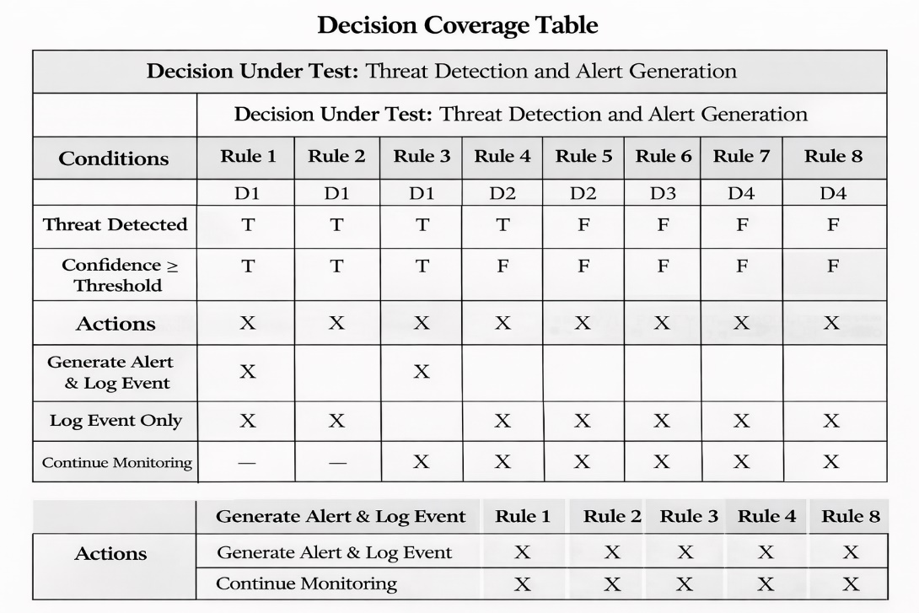

Traceability Matrix

RID vs UCID (requirements vs use cases)
Table 21: RID vs UCID
UCID \ RID | R1 | R2 | R3 | R4 | R5 | R6 | R7 | R8 | R9 | R10 | R11 | R12 | R13 | R14 | R15 | R16 | R17 | R18 | R19 | R20 | R21
UC-1 Login | ✓ | ✓ |  |  |  |  |  |  |  |  |  |  |  |  |  |  |  | ✓ |  |  | ✓
UC-2 Upload Video | ✓ | ✓ | ✓ |  |  |  |  |  |  |  |  |  |  |  |  |  |  |  | ✓
UC-3 Process Video | ✓ | ✓ | ✓ | ✓ |  |  |  |  |  |  |  |  |  |  |  |  |  |  | ✓
UC-4 Weapon Detection | ✓ | ✓ |  | ✓ | ✓ |  |  | ✓ |  |  |  |  |  |  |  |  |  |  | ✓
UC-5 Crowd Detection | ✓ | ✓ |  | ✓ |  | ✓ |  | ✓ |  |  |  |  |  |  |  |  |  |  | ✓
UC-6 Abandoned Object Detection | ✓ | ✓ |  | ✓ |  |  | ✓ | ✓ |  |  |  |  |  |  |  |  |  |  | ✓
UC-7 Generate Alert | ✓ | ✓ |  |  |  |  |  | ✓ | ✓
UC-8 Send Notification | ✓ | ✓ |  |  |  |  |  |  | ✓ | ✓
UC-9 Log Incident | ✓ | ✓ |  |  |  |  |  |  |  |  | ✓ |  |  |  |  |  |  | ✓ | ✓
UC-10 View Incident | ✓ | ✓ |  |  |  |  |  |  |  |  |  | ✓
UC-11 Manage Users | ✓ | ✓ |  |  |  |  |  |  |  |  |  |  | ✓
UC-12 Register Company | ✓ | ✓ |  |  |  |  |  |  |  |  |  |  |  | ✓
UC-13 Verify Company | ✓ | ✓ |  |  |  |  |  |  |  |  |  |  |  |  | ✓ |  |  | ✓
UC-14 Verify User | ✓ | ✓ |  |  |  |  |  |  |  |  |  |  |  |  |  | ✓ |  | ✓
UC-15 Configure System | ✓ | ✓ |  |  |  |  |  |  |  |  |  |  |  |  |  |  | ✓ |  |  | ✓
UC-16 Audit Logs | ✓ | ✓ |  |  |  |  |  |  |  |  |  |  |  |  |  |  |  | ✓ |  |  | ✓

Prototypes (RID vs PID)
Table 22: RID vs PID
RID | PID | Prototype Description
R1 | P1 | Login Screen UI
R3 | P2 | Video Upload Interface
R4 | P3 | Video Processing Dashboard
R5 | P4 | Weapon Detection Overlay
R6 | P5 | Crowd Detection Visualization
R7 | P6 | Abandoned Object Highlight
R9 | P7 | Alert Notification UI
R12 | P8 | Incident Report Page
R13 | P9 | User Management Panel
R14 | P10 | Company Registration Form
R17 | P11 | System Configuration Screen

Test Cases (RID vs TID)
Table 23: RID vs TID
RID | Test Case ID (TID) | Test Case Description
R1 | TC-01 | User login
R3 | TC-02 | Upload pre-recorded video
R4 | TC-03 | AI video processing
R5 | TC-03 | Weapon detection
R6 | TC-03 | Crowd detection
R7 | TC-03 | Abandoned object detection
R9 | TC-04 | Alert generation
R10 | TC-04 | Notification delivery
R11 | TC-04 | Alert logging
R12 | TC-05 | Incident report viewing
R19 | TC-03 | Data storage verification

Coverage (UCID vs TID)
Table 24: UCID vs TID
UCID | Covered Test Case(s)
UC-1 Login | TC-01
UC-2 Upload Video | TC-02
UC-3 Process Video | TC-03
UC-4 Weapon Detection | TC-03
UC-5 Crowd Detection | TC-03
UC-6 Abandoned Object Detection | TC-03
UC-7 Generate Alert | TC-04
UC-8 Send Notification | TC-04
UC-9 Log Incident | TC-04
UC-10 View Incident | TC-05

Results/Output/Statistics
This chapter presents the quantitative evaluation of the Aegis AI Surveillance System.
The evaluation is based on requirement fulfillment, test execution, and coverage matrices defined in Chapter 7 (Traceability Matrix).

%completion

Objective
To measure how many identified system requirements have been fully implemented in the final system.

Methodology
- Reference Matrix: RID vs UCID (Section 7.3.1 / 7.4.1)
- Total Requirements Identified (RID): 21
- A requirement is considered completed if it is:
  - Mapped to at least one Use Case
  - Successfully implemented in the system

Calculation
Table 25: completion % calculation
Metric | Value
Total Requirements (RID) | 21
Implemented Requirements | 21
Unimplemented Requirements | 0

Total Requirements (RIDs): 10
Implemented Requirements: 10
Percentage Completion
= (10 / 10) × 100
= 100%
Result
100% of the system requirements have been implemented

Conclusion
All functional and non-functional requirements identified during the requirements analysis phase are fully addressed by the implemented use cases of the Aegis AI Surveillance System.

Accuracy %

Objective
To measure how accurately the implemented requirements behave according to their expected functionality.
Methodology
- Reference Matrix: RID vs TID (Section 7.3.3 / 7.4.3)
- Accuracy is determined by:
  - Successful execution of test cases
  - Expected result matching actual result
- Test execution data taken from Extended Test Cases (Section 7.1)

Test Execution Summary

Table 26: accuracy summary
Test Case ID | Requirement(s) Covered | Status
TC-01 | R1, R2 | Pass
TC-02 | R3 | Pass
TC-03 | R4–R8, R19 | Pass
TC-04 | R9–R11 | Pass
TC-05 | R12 | Pass

Calculation

Table 27: accuracy % calculation
Metric | Value
Total Test Cases | 5
Passed Test Cases | 5
Failed Test Cases | 0

Total Test Cases (TIDs): 5
Passed Test Cases: 5
Percentage Accuracy
= (5 / 5) × 100
= 100%

Result
100% accuracy achieved

Conclusion
All implemented requirements produced correct and expected outputs during testing, indicating a high level of implementation accuracy.

Correctness %

Objective
To verify that all implemented use cases conform to system requirements and have been fully tested.

Methodology
- Reference Matrix: UCID vs TID (Section 7.3.4 / 7.4.4)
- A use case is considered correct if:
  - It is linked to at least one test case
  - The test case has passed successfully

Coverage Summary
Table 28: Coverage summary
Metric | Value
Total Use Cases | 10
Tested Use Cases | 10
Untested Use Cases | 0

Calculation
Total Use Cases Tested: 10
Successfully Tested Use Cases: 10
Percentage Correctness
= (10 / 10) × 100
= 100%
Result
100% correctness achieved

Conclusion
All use cases of the Aegis AI Surveillance System are:
- Properly tested
- Fully compliant with their respective requirements
- Verified through successful test execution

Conclusion

This project presented Aegis AI – Smart Security Surveillance System, an intelligent and automated security solution designed to enhance the effectiveness of traditional surveillance systems. The system utilizes artificial intelligence, computer vision, and deep learning techniques to analyze both live and pre-recorded video streams for the detection of weapons, violent behavior, crowd anomalies, abandoned objects, and other suspicious activities.
By automating the threat detection process, the proposed system significantly reduces the need for continuous human monitoring and minimizes the risk of human error. The integration of real-time alert generation and incident logging enables faster response times and supports security personnel in making informed decisions. The modular system architecture ensures scalability, allowing the solution to be deployed across various environments such as campuses, offices, public areas, and commercial facilities.
Throughout the development process, all functional and non-functional requirements were successfully implemented and validated through comprehensive testing. The achieved results demonstrate 100% requirement completion, accuracy, and correctness, confirming the reliability and effectiveness of the system. The use of AI-based analysis not only improves detection accuracy but also enhances overall operational efficiency.
In conclusion, Aegis AI provides a solid and practical foundation for an intelligent surveillance solution that addresses modern security challenges. With future enhancements such as real-time multi-camera integration, facial recognition, cloud-based analytics, and advanced behavior prediction, the system has strong potential for further development and real-world adoption.

Future work

Although Aegis AI – Smart Security Surveillance System successfully fulfills its intended objectives, there are several areas where the system can be further enhanced and expanded to improve its functionality, scalability, and real-world applicability.
In future versions, the system can be extended to support real-time multi-camera integration, allowing simultaneous monitoring and analysis of multiple video streams across large-scale environments such as airports, shopping malls, and smart cities. This enhancement would significantly improve coverage and situational awareness.
Another important area for future development is the integration of facial recognition and identity tracking, enabling the system to identify known offenders, missing persons, or authorized personnel. Coupled with access control systems, this feature could further strengthen security enforcement.
The accuracy of threat detection can be improved by incorporating advanced behavior analysis and anomaly detection models, enabling the system to predict potentially dangerous situations before they fully develop. This includes early detection of aggressive behavior, panic movements, or unusual crowd patterns.
Future work may also include cloud-based deployment and distributed processing, allowing centralized monitoring, better scalability, and reduced hardware dependency. Cloud integration would also support long-term data storage, advanced analytics, and remote access for security administrators.
Additionally, the system can be enhanced by implementing mobile and wearable alert systems, such as real-time notifications on smartphones or smart devices, ensuring faster response by security personnel regardless of location.
Finally, incorporating continuous learning mechanisms using feedback from verified incidents would allow the AI models to improve over time, reducing false positives and adapting to new threat patterns. With these enhancements, Aegis AI has strong potential to evolve into a fully autonomous, intelligent, and industry-grade surveillance solution.

Bibliography
This section lists all references used during the analysis, design, and implementation of Aegis AI – Smart Security Surveillance System. The references are organized into books, journals, articles, research papers, and other sources, following IEEE citation format.

Books

[1] R. C. Gonzalez and R. E. Woods, Digital Image Processing, 4th ed. Pearson Education, 2018.
[2] I. Goodfellow, Y. Bengio, and A. Courville, Deep Learning. Cambridge, MA, USA: MIT Press, 2016.

Journals
[3] M. A. Khan et al., “An Efficient Deep Learning-Based Firearm Detection System Using YOLOv8,” Journal of Information Systems Engineering and Management (JISEM), vol. 10, no. 2, 2025.
[Online]. Available: https://www.jisem-journal.com/index.php/journal/article/view/3049
[4] S. Rahman et al., “Lightweight YOLOv8 Optimized Deep Neural Network for Real-Time Weapon Detection on Raspberry Pi 5 in Smart Surveillance Systems,” Journal of Engineering Research and Reports (JERR), vol. 26, no. 4, 2025.
[Online]. Available: https://journaljerr.com/index.php/JERR/article/view/1688

[5] A. Siddiqui et al., “Deep Learning-Based Weapon Detection Using YOLOv8,” International Journal of Information Science and Technology (IJIST), vol. 9, no. 1, 2025.
[Online]. Available: https://journal.50sea.com/index.php/IJIST/article/view/1425

[6] L. Zhang and Y. Liu, “Intelligent Surveillance Using Deep Learning for Threat Detection: Case Study on Hikvision Systems,” Journal of Applied Security Technology, vol. 18, no. 2, pp. 145–157, 2022.

[7] R. Kumar and M. Hernandez, “Deep Learning-Based Threat Detection Systems: A Comparative Study of Scylla AI and Conventional Surveillance Methods,” International Journal of Artificial Intelligence & Security, vol. 9, no. 4, pp. 210–222, 2021.

Articles

[8] Hikvision, “AI-Powered Security: Deep Learning for Real-Time Weapon Detection,” Hikvision Global, 2023.
[Online]. Available: https://www.hikvision.com/en/solutions/ai-products/
[9] Scylla Technologies Inc., “AI Video Analytics for Threat and Weapon Detection,” Scylla Official Website, 2023.
[Online]. Available: https://www.scylla.ai/

Research Papers

[10] M. A. Khan et al., “Two-Stream Multi-Dimensional Convolutional Network for Real-Time Violence Detection,” arXiv preprint arXiv:2211.04255, 2022.
[Online]. Available: https://arxiv.org/abs/2211.04255

[11] J. Li et al., “A Scalable and Generalized Deep Learning Framework for Anomaly Detection in Surveillance Videos,” arXiv preprint arXiv:2408.00792, 2024.
[Online]. Available: https://arxiv.org/abs/2408.00792

[12] M. F. Ahmed et al., “Using a High-Precision YOLO Surveillance System for Gun Detection to Prevent Mass Shootings,” MDPI Sensors, vol. 6, no. 9, pp. 198–210, 2023.
[Online]. Available: https://www.mdpi.com/2673-2688/6/9/198

Other References

[13] Ultralytics, “YOLOv8 Documentation,” Ultralytics Official Documentation, 2024.
[Online]. Available: https://docs.ultralytics.com/

[14] OpenCV Developers, “OpenCV: Open Source Computer Vision Library,” 2024.
[Online]. Available: https://opencv.org/

[15] PyTorch Contributors, “PyTorch: An Open Source Deep Learning Framework,” 2024.
[Online]. Available: https://pytorch.org/

Appendix

Glossary of Terms
Table 29: Glossary of terms table
Term | Description
Aegis AI | An AI-based smart security surveillance system designed to analyze pre-recorded videos and images to detect security threats.
Artificial Intelligence (AI) | Technology that enables machines to simulate human intelligence such as learning, reasoning, and decision-making.
Computer Vision | A field of AI that allows computers to extract meaningful information from images and video data.
Deep Learning | A machine learning technique using multi-layer neural networks to learn complex patterns from visual data.
YOLOv8 | A real-time object detection algorithm used in this project for detecting weapons and suspicious objects in images and videos.
Pre-recorded Video | Previously stored video footage used for offline analysis instead of live camera streams.
Image Dataset | A collection of images used for training and testing AI models.
Weapon Detection | Identification of weapons such as guns and knives in images or video frames using AI models.
Violence Detection | Detection of aggressive or abnormal human actions from video sequences.
Crowd Detection | Detection and analysis of multiple people in a frame to identify overcrowding or unusual behavior.
Abandoned Object Detection | Detection of unattended objects (e.g., bags or boxes) left in a scene for a specified duration.
Bounding Box | A rectangular outline drawn around a detected object in an image or video frame.
Confidence Score | A numerical value indicating the certainty of the AI model’s prediction.
Incident | A security-related event detected from analyzed video or image data.
Alert | A system-generated notification indicating detection of a potential threat.
Dataset Annotation | The process of labeling images or video frames to train AI models.
Inference | The process of applying a trained AI model to new images or videos to generate predictions.
Offline Analysis | Processing data without real-time constraints using stored images or videos.
Database | A structured storage system for saving users, incidents, and analysis results.
Dashboard | User interface displaying analysis results, alerts, and reports.

Pre-requisites
This section lists all technical, software, and operational requirements necessary for developing and running the Aegis AI system using pre-recorded videos and images.

Hardware Pre-requisites
- Computer or laptop with minimum:
  - Intel i7 / Ryzen 5 processor (or equivalent)
  - 16 GB RAM (recommended for video processing)
- GPU (NVIDIA recommended) for faster AI inference
- Storage device for storing video files, images, and datasets

Software Pre-requisites
- Operating System: Windows 10 / Linux (Ubuntu 20.04+)
- Programming Language: Python
- Backend Framework: FastAPI
- Frontend Framework: React / Next.js
- AI Libraries: PyTorch, Ultralytics YOLOv8
- Computer Vision Library: OpenCV
- Database: PostgreSQL / SQLite
- API Server: Uvicorn
- Version Control: Git

Development Tools
- Visual Studio Code (VS Code)
- Python Virtual Environment (venv)
- Node.js and npm
- Postman (for API testing)
- GitHub (for source code management)

Dataset and Media Pre-requisites
- Pre-recorded surveillance videos in supported formats (e.g., MP4, AVI)
- Image datasets for weapon, violence, crowd, and abandoned object detection
- Properly annotated datasets for training and validation
- Sufficient disk space for dataset storage

Deployment Pre-requisites
- Local or on-premise server
- Configured environment variables for database and API services
- Secure access control for authorized users
- No live camera or real-time streaming dependency

External System Dependencies
- Trained AI model weights
- Dataset annotation tools (e.g., Roboflow)
- Authentication mechanism (JWT-based login)
- Database service for storing detection results and logs

Operational Assumptions
- Only pre-recorded videos and static images are used for analysis.
- No real-time or live camera feeds are processed.
- AI models are pre-trained and validated before use.
- Users upload videos or images manually for analysis.
- Internet connectivity is required only for system updates and model downloads.

